Section 7: Information services

One of the most important tasks of a resource centre is to make information available and encourage people to use it, by offering a range of information services. Information services should improve access to information, not only for people who can come and visit the resource centre, but also for those who are based far away, or who cannot come in for other reasons. This section includes:

7.1 Developing a strategy
7.2 Staffing and opening hours
7.3 Introductory sessions and information skills
7.4 Advisory services
7.5 Lending
7.6 Photocopying
7.7 Document supply
7.8 Referral services
7.9 Current awareness services
7.10 Abstracts
7.11 Enquiries services
7.12 Information packs
7.13 Newsletters

Related sections are:

1.2 Strategic planning
2.3 Financial planning
5.3 Assigning keywords
6.7 The World Wide Web
6.8.2 How to design a database
6.9.4 Electronic conferences
8.3 Networks and networking
9 Monitoring and evaluation

7.1 Developing a strategy

Different resource centres provide different information services, depending on users’ needs and the resource centre’s capacity. Although this section describes a number of different services, it is important to consider the needs of the resource centre's users, and the resources available (funds and staff time), and provide only those services that match these criteria.

If the resource centre is small, and has only limited staff time and financial resources, it may be sufficient to organise the materials carefully, ensure that they are kept up to date (by purchasing new editions and new titles), and provide users with skills for using the materials effectively.

The most commonly provided services include lending, reservation, advisory services, literature searches and photocopying. A larger resource centre with more staff time and resources could offer more services. A resource centre whose users are at a distance would have to consider which services would help it to reach out to the users.

A strategy for information services will need to be developed as part of the overall strategy for the resource centre (see Section 1.2: Strategic planning).

Information services can provide an opportunity for income-generation. Many resource centres generate some income by charging for services such as searches, reservations and photocopying. Decisions about charging should be made as part of the financial planning process (see Section 2.3: Financial planning).

7.2 Staffing and opening hours

Preferably, the resource centre should be staffed whenever it is open. Staff absences due to holidays or sickness should be covered. Some resource centres set up a rota system, in which various people, including health workers, tutors and students, take it in turns to be on duty in the resource centre. Everyone who does resource centre duty needs to be familiar with the collection and the services that are offered.

A smaller resource centre which is only open to staff of the organisation that it is part of, could be open when there is no one to staff it. However, this would mean that the collection would be less secure, and that no one would be available to help users find and use information.

It is therefore important to think carefully about how many people are available to be on duty in the resource centre, and how many hours it would be useful for the resource centre to be open.

7.2.1 Welcoming visitors
When people come to use the resource centre, it is important that they feel welcome. The opening hours should be made clear in any publicity material, so that people will not be disappointed to find the resource centre shut.

It is a good idea to have a visitors’ book for keeping records of visits. This could be an exercise book in which visitors write down their name and organisation, and the date that they visited the resource centre. It is useful to keep a record of who has visited the resource centre, where they come from and what they have found useful, to help evaluate the service. It is also useful to ask visitors for other information as well, such as their occupation, what subject areas they are interested in, and whether they have any comments. These questions could be included in the visitors’ book, or visitors could be asked to complete a form.

7.3 Introductory sessions and information skills

Some people may not know how to use materials in the resource centre. They may not be aware of all the different formats of information that are available, or they may not know how to use the catalogue or how to browse the shelves using the classification system. An important role for resource centre staff is therefore to help users develop skills in finding and using information, including:

- finding materials – using the classification scheme and catalogue
- using contents lists and indexes
- taking notes and quoting sources
- knowing what to use materials for, such as:

- diagnosing, treating and giving advice on specific health problems
- as teaching tools
- to provide ideas for preparing health promotion sessions or making teaching materials
- as a basis for workshop discussions
- to solve problems
- to assist with research or preparing an assignment.

7.4 Advisory services

Resource centre staff usually help people find the information they need by discussing their needs with them in a reference interview, and helping them find materials themselves or carrying out a literature search.

7.4.1 Reference interviews
A visitor to the resource centre might say: ‘Can you show me the materials on malaria.’ After discussing the user's needs with them, the resource centre staff might find that the user wants to know about new developments in malaria prevention. The user could then directed to materials specifically about malaria prevention, saving them the need to look at all the materials on malaria.

Some users ask for a specific publication, which they believe is the only one containing the information they need. However, by discussing their needs with them, it might be possible to refer them to a better source of information.

Discussions such as these are often called ‘reference interviews’. They vary in length according to the needs of the user. If a user has a query that will take a lot of time to deal with - for example, if it will require a literature search - it is usually best to book a time (see Section 7.4.2).

Resource centre staff know more about the collection than anyone else and are there to provide guidance. However, it is not practical to spend much time with every user every time they come into the resource centre. People visiting for the first time will require more advice than regular users. Regular users may need help if they are looking for information on a new subject area. Staff will need to ask them what they need the information for, whether they need particular types or formats of information, and how soon they need it.

It is best to direct users to materials that will probably be useful, but encourage them to ask for more help if they need it.

7.4.2 How to carry out a literature search
Literature searches mean searching (looking through) sources such as catalogues, databases, bibliographies, indexes, periodicals, books, newsletters, CD-ROMs, e-mail and the Internet, or contacting other organisations, to locate materials on a particular subject. Literature searches form an important part of an advisory service. It can be useful to show users how to carry out database searches themselves.

To carry out a literature search, it is important to be clear what is needed. Find out from the user:
- what subject area(s) the material must cover
- how the information is to be used (for example, training, health education, personal updating)
- who the material is for (for example, health workers, students, the community)
- what format is preferred (for example, articles, books, videos)
- what time-span the material should cover (for example, new material for a newsletter, or both older and new material for a subject overview)
- how soon the information is required.

Subject areas Decide what keywords to use to describe the subject (see Section 5.3: Assigning keywords). Use these keywords to search the resource centre’s catalogue or database. Use these or similar subject terms to search other bibliographies and indexes.

How the information is to be used This will affect the type of material that is required. For example:
- for diagnosing or treating diseases – a handbook plus recent articles
- to present issues for discussion – videos, articles or a chapter of a book
- to develop a training course outline – training manuals, workshop materials or curriculum guidelines.

Who the material is for Knowing this helps staff to know, for example, whether to look for materials written in technical or non-technical language, or whether to look for illustrated materials.

What format is preferred If the user prefers a particular format, such as books or articles, there is no point spending time looking for materials in other formats. However, if the resource centre holds very useful materials in other formats, it is worth pointing this out. The user might not know that these are available, or might not have thought of using other formats. This is an example of how it helps to include all materials in the same catalogue (see Section 5.4.4: Filing catalogue cards).

What the time-span is This can help you know what format of materials to search for. If the user wants new information on a subject that they know about, the best sources will be newsletters, journals and current awareness bulletins. If the user needs to learn about a subject that is new to them, the main sources of information will be books and reports.

How soon the information is required This helps you know which sources of information to search. If the information is needed quickly, you will need to limit the search to materials in the resource centre collection (excluding any on loan), or full text materials available via the Internet. If there is more time, you might be able to order new materials for the resource centre, or borrow materials from another resource centre through an inter-library loan or document delivery service. You could also ask questions on an e-mail discussion list (see Section 6).

It is useful to keep a record of literature searches, as this can be used for evaluating the services, updating needs assessment information and developing the collection.

Details of searches could be kept in a notebook. They should include the date, subject area, types of materials used (such as CD-ROM, catalogue, database or reference books), whether the required information was found, and whether the user was referred elsewhere.

TIP: Getting to know the collection

The time and effort spent on advisory services is useful to resource centre staff, as well as users. It helps staff learn about the collection and users’ needs. This is important for updating the collection policy and knowing what information services to offer.

Advisory services also help resource centre staff to review what details need to be included in the resource centre’s catalogues or databases, such as whether materials contain illustrations.

Recording the results of searches can make searching quicker. You could set up a database field (see Section 6.8.2) named ‘Useful for’, listing which materials have been useful for a particular training session, or as source material for a particular publication, or to support a particular health education activity. Next time a similar event takes place, you could do a quick search by seeing what was used the last time, and use the keywords that describe these materials to find any newly added materials that might also be useful.

7.5 Lending

Lending allows users to read or view materials in their own time. It is especially useful for users who are based some distance from the resource centre.

There is, however, a problem with lending - the failure to return materials. For this reason, some resource centres only lend materials to staff in the same organisation, or to users in the same town as the resource centre. If materials are to be lent to people who are based further away, there will need to be a system to prevent materials from becoming lost. For example, a deposit could be charged for borrowing materials –- a sum of money that would be returned to the borrower when they stop being a member of the resource centre, or kept if they fail to return the materials.

If the postal system is unreliable, registered post could be used for any materials that need to be posted to or from the resource centre. Registered post is expensive, and the cost would need to be covered by, for example, charging an extra fee for materials supplied through the post.
Health Information Project loans policy and procedures

- The following people may borrow materials: Tutors, students and other Ministry of Health personnel.

- The number of items that may be borrowed varies, depending on the type of user: Tutors are allowed six items and students three items.

- Materials may be borrowed for up to two weeks. They may be borrowed again if not required by another user.

- All materials may be borrowed.

- If an item is overdue and a reminder has been sent, a fine of [small amount] per day will be charged.

- If an item is lost or damaged, the user will be required to pay the cost of replacing or repairing it.

- When lending an item, either
- the name and membership number should be written in the loans book and the date when the item is due back should be written or stamped on the due date label inside the book, or
- the loan card should be placed inside the user's loan pocket and filed by the date the item is due back, and the same date written or stamped on the due date label (loan slip) inside the book.

- To check for outstanding loans, a check should be made once a week (on the same day each week) to see what items are overdue, and a reminder should be sent to the member who borrowed the item(s).
Materials that cannot be replaced, such as those that are out of print or are very expensive, could be unavailable for lending. Alternatives to lending include current awareness bulletins, enquiries services, information packs and newsletters (see Sections 7.9, 7.11, 7.12 and 7.13).

Before offering a lending service, it is important to decide how many materials a person may borrow and how long they may keep them. These decisions will depend on the number of materials in the resource centre, the number of users, how easily users can come into the resource centre, and how far users are based from the resource centre. A sample loans policy is given in Section 7.5.1.

7.5.1 Sample loans policy and procedures

7.5.2 How to set up a lending system
It is advisable to have a system for identifying and registering users who borrow materials. For example, users could be asked to complete a membership form (see Section 7.5.3: Sample membership form). Membership forms should be filed alphabetically by surname so that details can be checked when required.

If there are only a few users who borrow materials, a simple register could be kept in a large exercise book. Details of the material, the person who has borrowed it and the date, could be entered in the register each time material is borrowed. When the material is returned, the return date is added to indicate that the material is back in the collection.

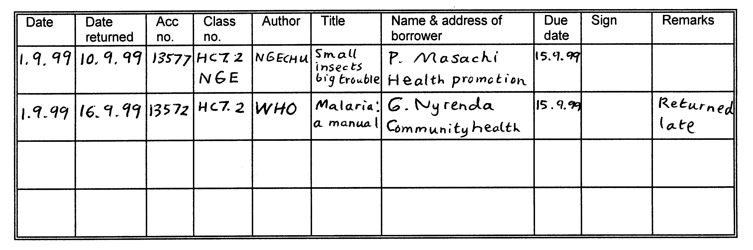
If many users borrow materials, a card system is better than an exercise book. Each material will need the following:
- a ‘loan slip’ – a small piece of paper pasted onto the first right-hand page of a book, or inside a video box. The piece of paper shows details of the author, title, classification number and accession number, and has spaces marked out for the borrower’s name and date to be returned
- a ‘loan card’ – a card containing details of the accession number, classification number, author and title – kept in a pocket attached inside the cover of the book or video.

Each user is issued with a number of ‘loan pockets’ giving details of their name, department and organisation. The number of pockets that they are given depends on how many materials they may borrow at the same time. Loan pockets can be kept either by the user or the resource centre, depending on which is felt to be more practical.

When someone borrows a material, the loan slip is stamped with the date the material is due back, the loan card is put into a loan pocket, and the loan pocket is then filed according to the date that the material is due to be returned.

It is also useful to have a standard letter or form to send to people who have borrowed materials that are overdue (see Section 7.5.4).

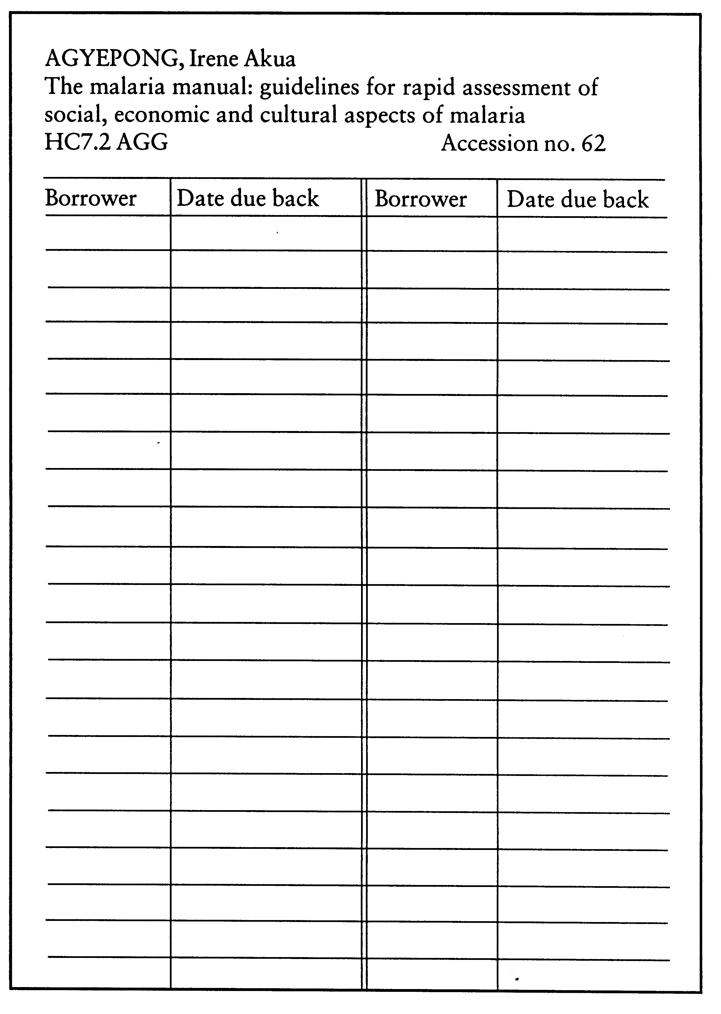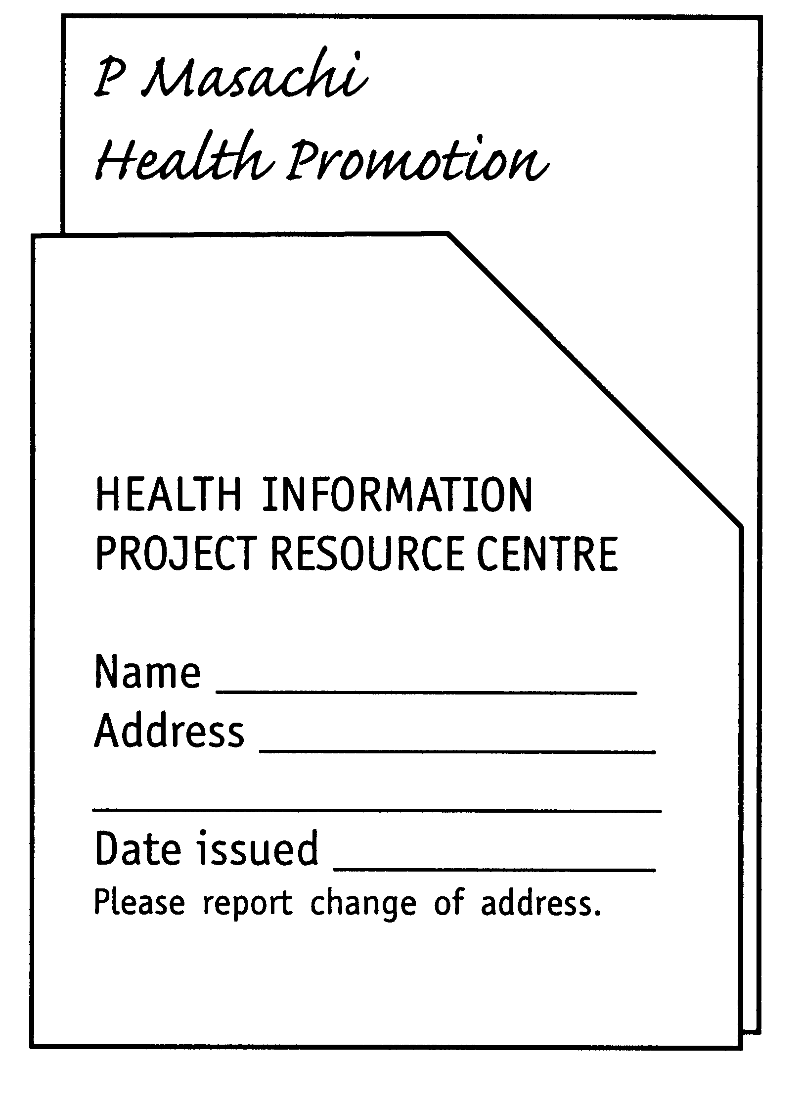

Loan pocket and loan card

Loan slip

7.5.3 Sample membership form

Health Information Project resource centre membership form

Membership no. __________________________________________________
Name ___________________________________________________________
Place of work ____________________________________________________
Address of work __________________________________________________
_________________________________________________________________
_________________________________________________________________
Telephone number ________________________________________________

Proof of identify (e.g. student card, letter from workplace if from another organisation)
________________________________________________________________

I agree to the rules of the resource centre which are stated at the bottom of this form.

Signed ________________________________ Date _______________________

Rules

- I agree to take care of materials in the resource centre or borrowed by me, and agree to return them in the same condition in which they were borrowed.

- I agree to return materials on the date due or, if any difficulties arise, to advise the resource centre staff immediately.

- If an item that I have borrowed is lost or damaged in a way that makes it unusable, I agree to pay the replacement cost of the item.

7.5.4 Sample overdue books reminder

Health Information Project
Capital City
PO Box 111
Ghana

Reference number __________________
Date ________________________

Dear _________________________

Resource materials

This is to remind you that the following materials are now overdue. Please return the materials as soon as you receive this reminder.

The items are:

- Author ________________________________
Title ____________________________________
Accession no. ____________________________

- Author _______________________________
Title ___________________________________
Accession no. ____________________________

- Author _______________________________
Title ____________________________________
Accession no. ____________________________

Yours sincerely

I C Books
Resource Centre Officer

7.5.5 Reservation
If a user needs material that is on loan, staff might offer to reserve it for them once it is returned. If a user needs materials that are not held in the resource centre, staff might offer to include it in the next batch of orders, or borrow it from another resource centre, and notify them when it has been received.

7.5.6 Inter-library lending
Inter-library lending means one library or resource centre lending materials to another. It can enable users to obtain materials that are not in their local resource centre. Inter-library lending is often organised by networks (see Section 8.3: Networks and networking), although some national libraries will lend to resource centres for a membership fee or deposit, intended to cover loss or damage to materials.

It can be very useful to borrow materials through a network. If the network requires materials to be lent in return, and there is a worry about what might happen to them, materials could be lent on the basis that they must only be used in the borrower's resource centre, and not taken away.

7.6 Photocopying

Photocopying articles from periodicals or pages from books makes information more easily accessible. If the resource centre offers a photocopying service, the resource centre budget needs to include photocopier maintenance and accessories such as paper and toner (See Section 2.3: Financial planning).

It is important to be aware of copyright laws, which allow only a few pages to be photocopied unless permission is given. Some publishers are happy for their materials to be photocopied or adapted for education and training without being asked permission. If so, they always state this clearly in the publication. It can be useful to add copyright details to notes about the publication in the catalogue, so that these are known before the material is taken off the shelf.

It is best to check about copyright in the country concerned. The national library usually has this information. However, the following can usually be photocopied:

- one article in an issue of a periodical (such as a newsletter or journal)
- one chapter of a book, or 10 per cent of the publication, whichever is less
- no videos, unless permission is given
- no computer software, unless permission is given (except to make a single security backup)
- a small number of records from a commercial bibliographic database such as Medline or POPLINE, either to print and post, or to e-mail the information to a user who cannot visit the resource centre.

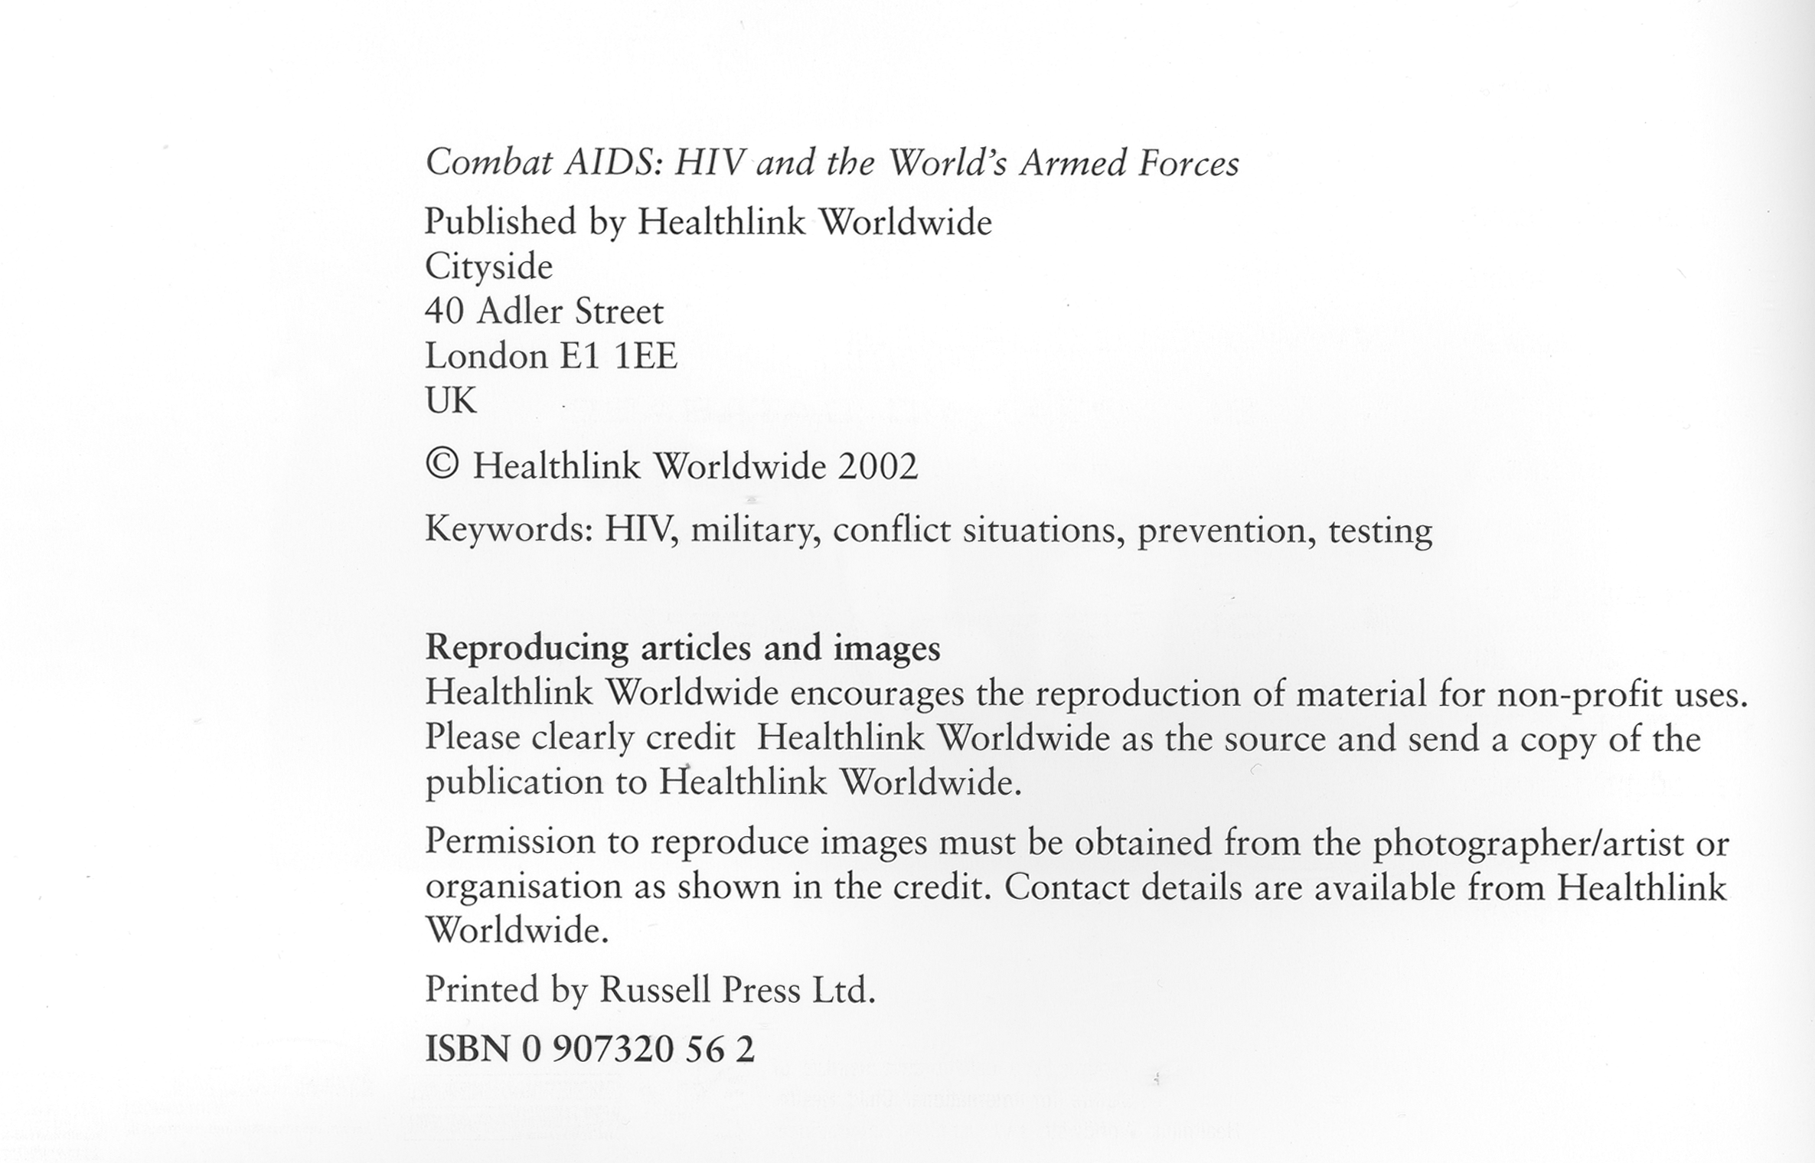

Example of permission for reproduction

7.7 Document supply

The supply of photocopies to users who cannot visit the resource centre, or to other resource centres, is often called document supply.

Users may need to see articles in periodicals or chapters in books that are not held by the resource centre. Resource centre staff can enable them to do this by asking other resource centres for document supply services. Staff can develop a knowledge of what materials are available from other resource centres by providing referral services (see Section 7.8).

Document supply is one of the services that network members often provide for each other (see Section 8.3: Networks and networking). This is usually on the basis of mutual support – resource centres are expected to supply a similar number of materials to the number that they request.

If document supply is requested from resource centres and libraries that are not part of a network, they will usually make a charge. Charges vary, but can be quite expensive – for example, up to GB£5/US$10 for an article.

To comply with copyright regulations, it is important to keep records of photocopied materials obtained and supplied via document supply. Records of requests for materials should include details of what was requested, who requested it, the date it was requested, the date it arrived and the organisation that supplied it. Records of materials supplied to other organisations should included details of what was requested, the organisation that requested it, the date it was requested and the date the photocopies were sent.

7.8 Referral services

Referral means suggesting where a user can find information that is not available in the resource centre. Referral services are among the most important services offered by a resource centre.

No resource centre can hold all the materials available on all the subjects of interest to their users. It is important to know about other sources of information, so that users can be referred to them if necessary.

Other sources of information may include members of a network (see Section 8.3: Networks and networking), or other resource centres, either in the same country or elsewhere, that provide enquiries services (see Section 7.11) or document supply services (see Section 7.7).

It is possible to find out about other resource centres and information services by:
- scanning or reading newsletters on the subject areas that the resource centre covers
- networking with staff in other resource centres – those in the same country specialising in any subject area, and those specialising in similar subjects, either in the same country or elsewhere
- joining e-mail discussion groups, such as ASIALIB (see Section 6.9.4)
- searching the World Wide Web (see Section 6.7).

7.9 Current awareness services

A current awareness service is a way of letting users know about materials that have been newly received in the resource centre. Current awareness services include:
- current awareness bulletins
- selective dissemination of information
- circulating documents
- displaying newly acquired materials and using noticeboards.

Current awareness bulletins contain details of new materials, book reviews, announcements about meetings and conferences, and news of resource centre activities. Current awareness bulletins are particularly useful for larger resource centres, or for resource centres whose users are widely dispersed. They help users to keep up with a range of new developments. They also help to generate specific enquiries, which resource centre staff can deal with more efficiently than general enquiries. The practicalities of producing a current awareness bulletin are similar to those of producing a newsletter (see Section 7.13: Newsletters).

Selective dissemination of information (SDI) means notifying individual users, or groups of users, about materials that will interest them. It is possible to keep up-to-date with what different individuals or groups are interested in through ongoing needs assessment work, advisory services and reference interviews.

Circulating materials means passing materials to individuals to pass in turn to others on a circulation list. There is a disadvantage to this service, in that materials can take a long time to reach the last person on the list. It is often more useful to circulate a contents page than the actual item.

Displaying newly arrived materials helps users to notice new materials, and makes the resource centre look lively and attractive. Noticeboards can be very useful for displaying the contents pages of newly received periodical issues, or copies of the covers of new books, reports and audiovisual materials. Displays are useful for attracting the attention of non-regular resource centre users, and visitors to the organisation.

7.10 Abstracts

Abstracts are summaries of articles, books or reports. They are a useful way for resource centre staff or users to identify relevant materials. They are also useful for providing more detailed information about materials held in the collection, either in current awareness bulletins or on a database.

There are three types of abstract:
- Indicative abstracts are short, simple and objective. They describe the theme of the article or publication.
- Informative abstracts are longer and more thorough. They describe the objectives and conclusions of the article or publication, as well as the contents.
- Evaluative abstracts (also known as critical abstracts) are subjective. They evaluate the contents of the article or publication.

Abstracts are often included in bibliographies and bibliographic databases. They are sometimes included in current awareness bulletins. Videos and articles in periodicals often carry an author’s or publisher’s abstract. The abstracts that are published with the material can be included in a bibliographic database record or current awareness bulletin, in order to help users decide how useful the materials might be for their needs.

Only larger resource centres have the capacity to produce abstracts for all their materials. Abstracting is time-consuming and requires skills in summarising, analysing and writing. If the resource centre is considering producing abstracts, abstracting needs be to compared with allocating keywords (see page Section 5.3: Allocating keywords). Keywords can provide a similar indication of the content, audience and level of a material, and make it easy to identify relevant materials, but cannot provide information about the conclusions of an article, or evaluate its content.

7.10.1 Examples of abstracts
These abstracts describe an article in the East African Medical Journal about research into the use of malaria prophylaxis among pregnant women.

Indicative abstract
Assesses how the knowledge of malaria and the perceived effectiveness of malaria control methods affect the use of malaria prophylaxis by pregnant women attending an antenatal clinic in Tanzania.

Informative abstract
Knowledge, perception and use of malaria prophylaxis was assessed among 301 pregnant women attending an antenatal clinic in Dar es Salaam, Tanzania. It was found that women with a high knowledge of malaria were more likely to use malaria prophylaxis than those with low knowledge. However, there was no significant association between knowledge of malaria and perceived effectiveness of the various methods of malaria control. Occurrence of malaria episodes was reported to be similar among users and non-users of malaria prophylaxis, probably owing to inconsistent use of malaria prophylaxis. It is suggested that in addition to chemophrophylaxis, pregnant women should be encouraged to use bed nets in combination with mosquito repellants throughout the course of pregnancy.

Evaluative abstract
The article discusses research undertaken to assess knowledge, perception and utilisation of malaria prophylaxis in pregnant women attending an antenatal clinic in Dar es Salaam, Tanzania. It begins with a review of the current research literature on the adverse effects of malaria during pregnancy, the benefits of chemoprophylaxis, and issues relating to non-compliance.

It then details research methodology and results, and possible factors that might affect the results. As the research showed no significant associations, and the occurrence of malaria episodes was reported to be similar among users and non-users of malaria prophylaxis, suggestions are made concerning methods for the prevention of malaria during pregnancy.

7.11 Enquiries services

Enquiries services are a way of responding to requests for information from users who cannot come to the resource centre. Enquiries may be received by telephone, post, fax or e-mail. It is useful to develop a standard enquiries form to ensure that the resource centre has all the necessary details of what is required.

If the user is clear about what they want, it should be easy to send the information they require, if the necessary materials are in the resource centre, and there is a system for lending materials or sending photocopies.

However, it may be necessary to find out more clearly what is required. If the enquiry is made by phone, questions can be asked over the phone. Otherwise staff can write back, seeking clarification. For more details of the questions to ask, see Section 7.4.2: How to carry out a literature search.

It is usually worth preparing standard responses to enquiries on subjects that the resource centre receives a lot of enquiries about. A standard letter could be sent, perhaps accompanied by photocopies of useful articles. If facilities are available, it might be possible to produce one or more leaflets, booklets or information packs (see Section 7.12), to answer frequently asked questions. The user could be asked to contact the resource centre again if they need more information.

Enquiries services need to be monitored, to feed into the overall evaluation of the resource centre (see Section 9: Monitoring and evaluation). Keeping records of enquiries provides useful information for developing information services, and information about the needs of the users. The task of monitoring enquiries is made easier if enquiries forms are completed as each enquiry is made, and the information on the forms is collated every month.

TIP: Handling telephone enquiries
You may receive enquiries by telephone. When you answer a telephone:
- Have an enquiries form and pen ready.
- Give the name of the resource centre, and greet the caller.
- Write down the caller’s name, and the date and time of the call.
- Listen to what the caller says and make notes.
- Ask for further details if necessary, and read back to the caller the message you have written down.
- If the caller has to be kept waiting, give reassurances from time to time, so that they do not think they have been cut off or are being ignored.
- If the query cannot be dealt with immediately, write down the caller's telephone number, offer to ring them back and, if necessary, explain what will happen in the meantime.
- Ensure that the enquiries form is completed with details of the enquiry and the information you have provided.

7.12 Information packs

Information packs are an economical way of providing information about a particular subject area to users who cannot visit the resource centre.

Information packs usually take the form of folders (cardboard wallets) or envelopes containing a variety of materials, such as articles from newsletters and journals, photocopied pages from books, factsheets, posters, leaflets, materials developed within the organisation, or materials distributed free by other organisations working in the same subject area.

When developing an information pack as a resource to distribute to users, it is important to obtain permission from the publisher to include an item (text or illustrations) in a pack, unless the publisher has indicated that this is not necessary. The publisher will want to know the purpose of the pack and its target audience, the number of copies to be produced, and any charges to users (for example, to cover the cost of photocopying and distribution, or to make a profit to help the resource centre).

If producing a single pack to respond to an individual enquiry, it is not necessary to request permission from the publisher, provided copyright laws are followed (see Section 7.6: Photocopying).

Before any information packs are prepared, it is important to be sure that the right materials have been selected to go in them. This can be done by discussing the contents of a proposed information pack with members of the resource centre advisory committee, and or other key users. It can be useful to include a short evaluation form in the pack for users to complete and return. This can point to ways of improving future information packs.

Information packs should always include a contents list that provides details of the original source of each item (such as a book or periodical title, publisher and year published).

An information pack is not a static thing. It will need to be updated by adding new materials, as well as or instead of existing materials. It is important to keep the master photocopy of each of the materials included in an information pack, to ensure that each copy is of the same quality, and that time is not wasted looking for the original material each time a copy needs to be made. Alternatively, if the resource centre has a bibliographic database, codes could be added to the records of new materials to indicate that they are suitable for inclusion in the information pack.

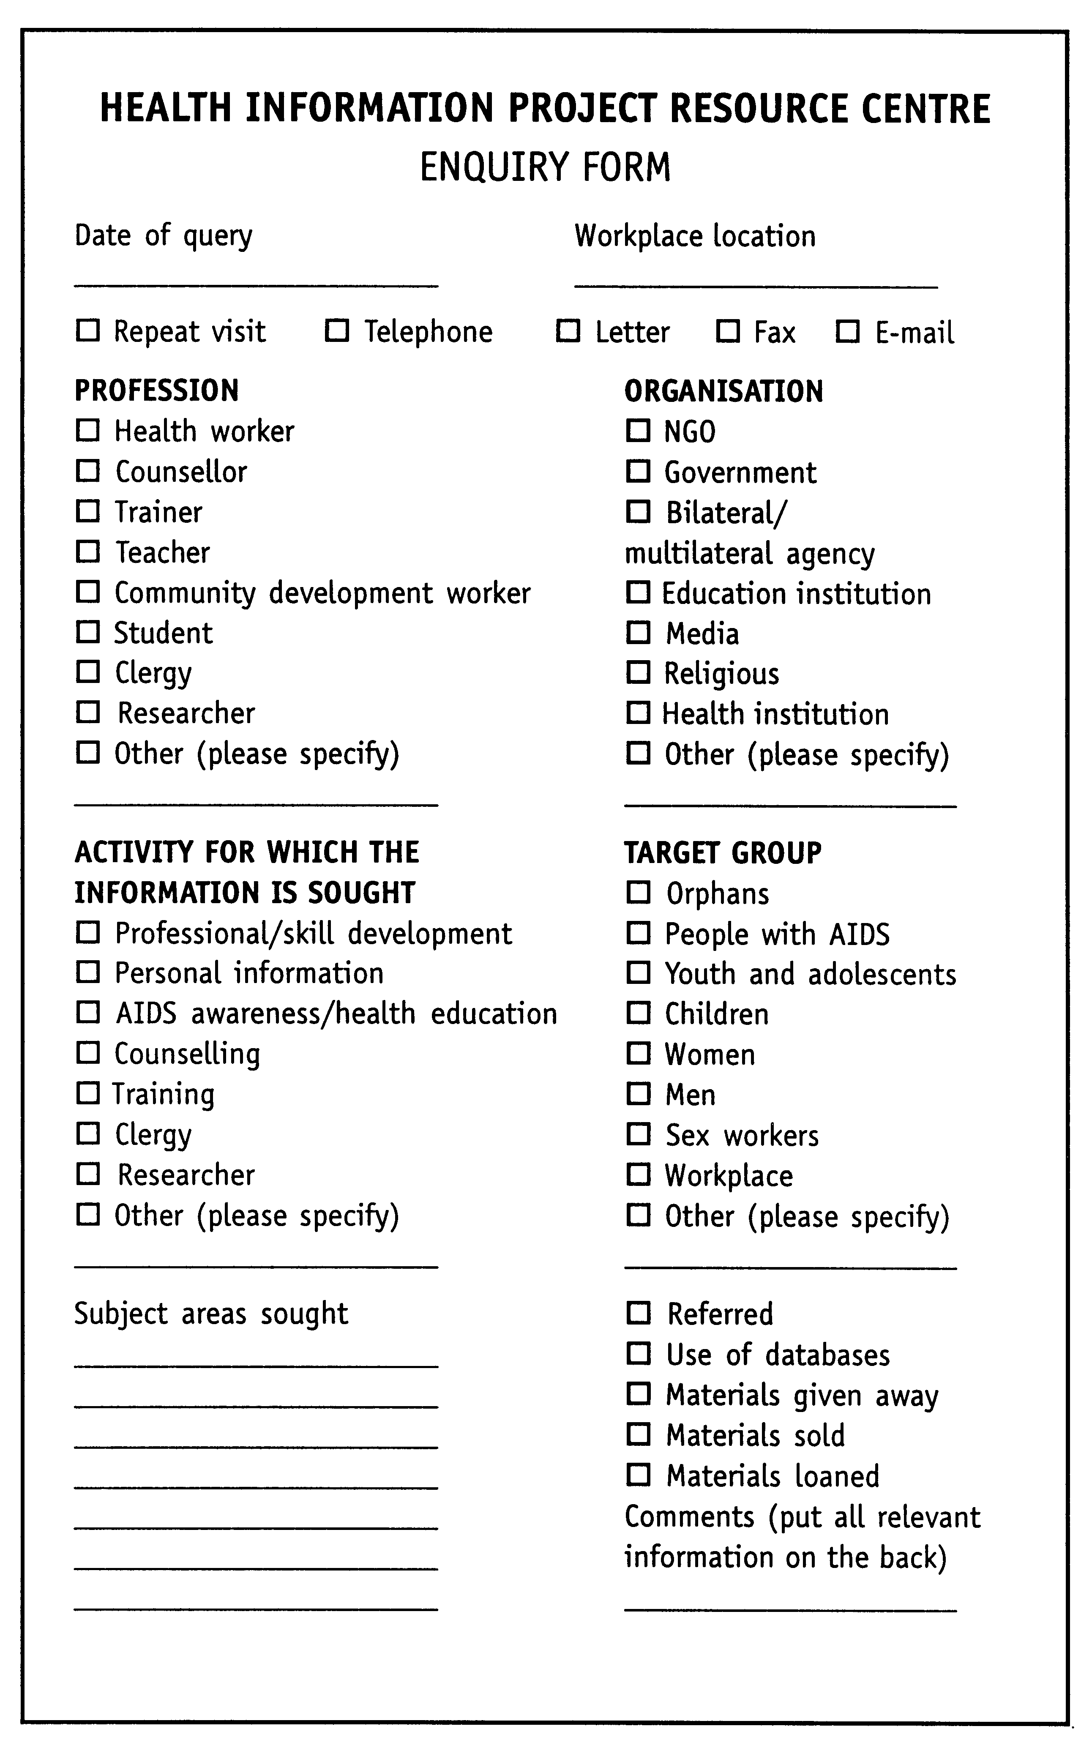

Sample enquiries form

7.13 Newsletters

Newsletters can be a useful way to disseminate topical information about local health issues and activities. They may include news about the resource centre, articles about local health problems and projects, research updates, details of new publications, training opportunities and conferences, and letters and questions from readers.

Newsletters have become easier to produce and more attractive to look at with the use of computers. To make a newsletter into a lively forum for the exchange of news and ideas, resource centre staff could involve local health workers or community groups in planning and providing information.

A few words of caution, however. A newsletter needs to have clear aims. It needs to be properly funded and staffed over a long period. Otherwise it can turn into a chore or a drain on resources. It is important to:
- identify who the readers will be, what their information needs are, and the purpose of the newsletter
- identify who will be responsible for planning, writing, editing, layout and administration (including staff and others who may be commissioned), what expertise they have and what training they may need
- decide how to distribute the newsletter (for example, by post, at the health centre, hospital, community centre or chemist)
- develop a realistic budget that takes into account all production and distribution costs, including salaries
- allow a realistic amount of time for the work and draw up a realistic schedule
- plan several issues in advance to avoid gaps.

