Section 5: Organising the information

This section looks at how to organise information in the resource centre so that users can easily find what they need. It includes:
5.1 Classifying materials
5.2 Developing a classification scheme
5.3 Assigning keywords
5.4 Cataloguing materials
5.5 Shelving, displaying and filing materials

Related sections are:
1.1 Assessing information needs
2.2 Advisory committees
3.3 Choosing furniture and equipment
6.8 Databases
8.2 Promoting the resource centre

This section assumes that a manual system is being used to catalogue materials. However, the same principles apply if a computer is used.

5.1 Classifying materials
TIP: Organising information
Organising information does not have to be complicated.
A useful tip is KIS - Keep It Simple

Classifying materials means identifying each material according to its subject, so that materials on similar subjects can be grouped together on the shelves. Classification schemes help to:
- direct users to the material that they need
- enable users to find related materials
- enable staff to know where to put materials.

Materials in small resource centres are sometimes classified using different colours to represent different subjects - different coloured dots are stuck onto the materials to indicate the subject. More usually, materials are classified using a combination of numbers and letters. The numbers and letters represent the main subject areas and subsidiary (other) subjects covered by the material.

Whatever the size of the resource centre, materials need to be classified in some way. A very small resource centre only needs a simple classification scheme, using a few broad subject headings, and a separate section on the shelves for general reference materials.

5.1.1 Choosing a classification scheme
There are two main types of classification scheme: universal and specialised. Universal classification schemes cover all subject areas. They include Universal Decimal Classification (UDC), Dewey, and Library of Congress. Specialised classification schemes include the National Library of Medicine (NLM). This is designed for medical libraries. It covers very clinical issues, and therefore does not cover all the areas covered by resource centres focusing on health or disability issues.

Resource centres that specialise in a particular subject often develop their own specialised classification scheme, such as the Healthlink Worldwide Primary Health Care Classification Scheme, and the Southern African HIV/AIDS Classification Scheme of the Southern African Network of AIDS Service Organisations (SANASO).

A suitable classification scheme can usually be identified by contacting the national public library service, library association or a university library. If the resource centre specialises in primary health care or disability issues in developing countries, it would be worth contacting Healthlink Worldwide.

5.1.2 How to classify materials
To classify materials, ask yourself:

- Is the material about a particular subject or subjects (for example, is it a book about health education or a video about counselling?) or is it more general (for example, is it a directory or atlas?) Find out by looking at the following:

- for books and other print materials: the title page, list of contents and introduction, preface or foreword
- for audiovisual materials: the title, description and any accompanying materials, and by watching a video, listening to an audio cassette, or looking at slides.

- If the material is about a subject, does it deal with one subject or several subjects?

- If the material deals with one subject, use that subject to classify it. Find the subject in the classification scheme and assign the corresponding classification number to the material.

- If the material deals with several subjects, can all these subjects be regarded as part of one broad subject? If so, use the broad subject to classify the material.

- If the material deals with several subjects that are not part of one broader subject, use the subject that is either most thoroughly covered by the material, or of main interest to users of the resource centre, to classify the material.

- Check that you are classifying materials on similar subjects consistently, by looking at several materials to which you have assigned the same classification number. You can do this by going to the shelves and looking at the materials that are already there.

- If the material is for general reference (such as a dictionary or atlas), you do not need to classify it. Place it in a section of the resource centre for general reference materials.

- If you have a lot of materials with the same classification number, you can distinguish them by putting the first three letters of the author’s name after the classification number. If there is no author, use the first three letters of the title. For audiovisual materials, use the producer’s name.

If the resource centre collection expands into new subject areas (for example, emerging diseases such as hypertension), you may need to add new subjects to your classification scheme. Most classification schemes are designed to make it easy to add new subjects when necessary. Details of how to extend the classification scheme are included in Section 5.2.2.

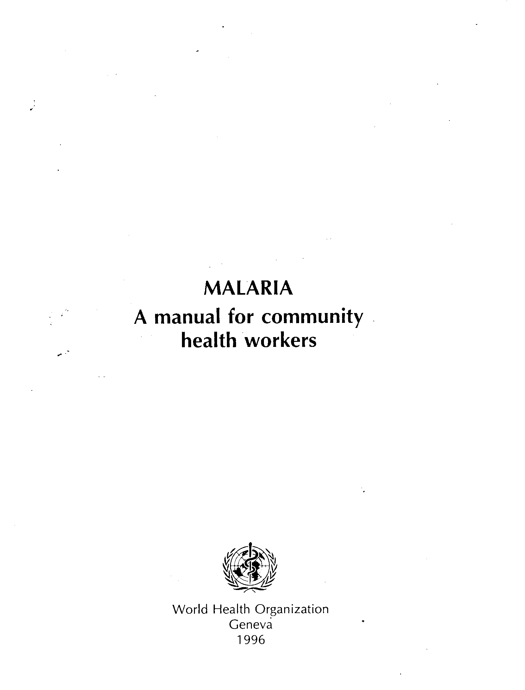
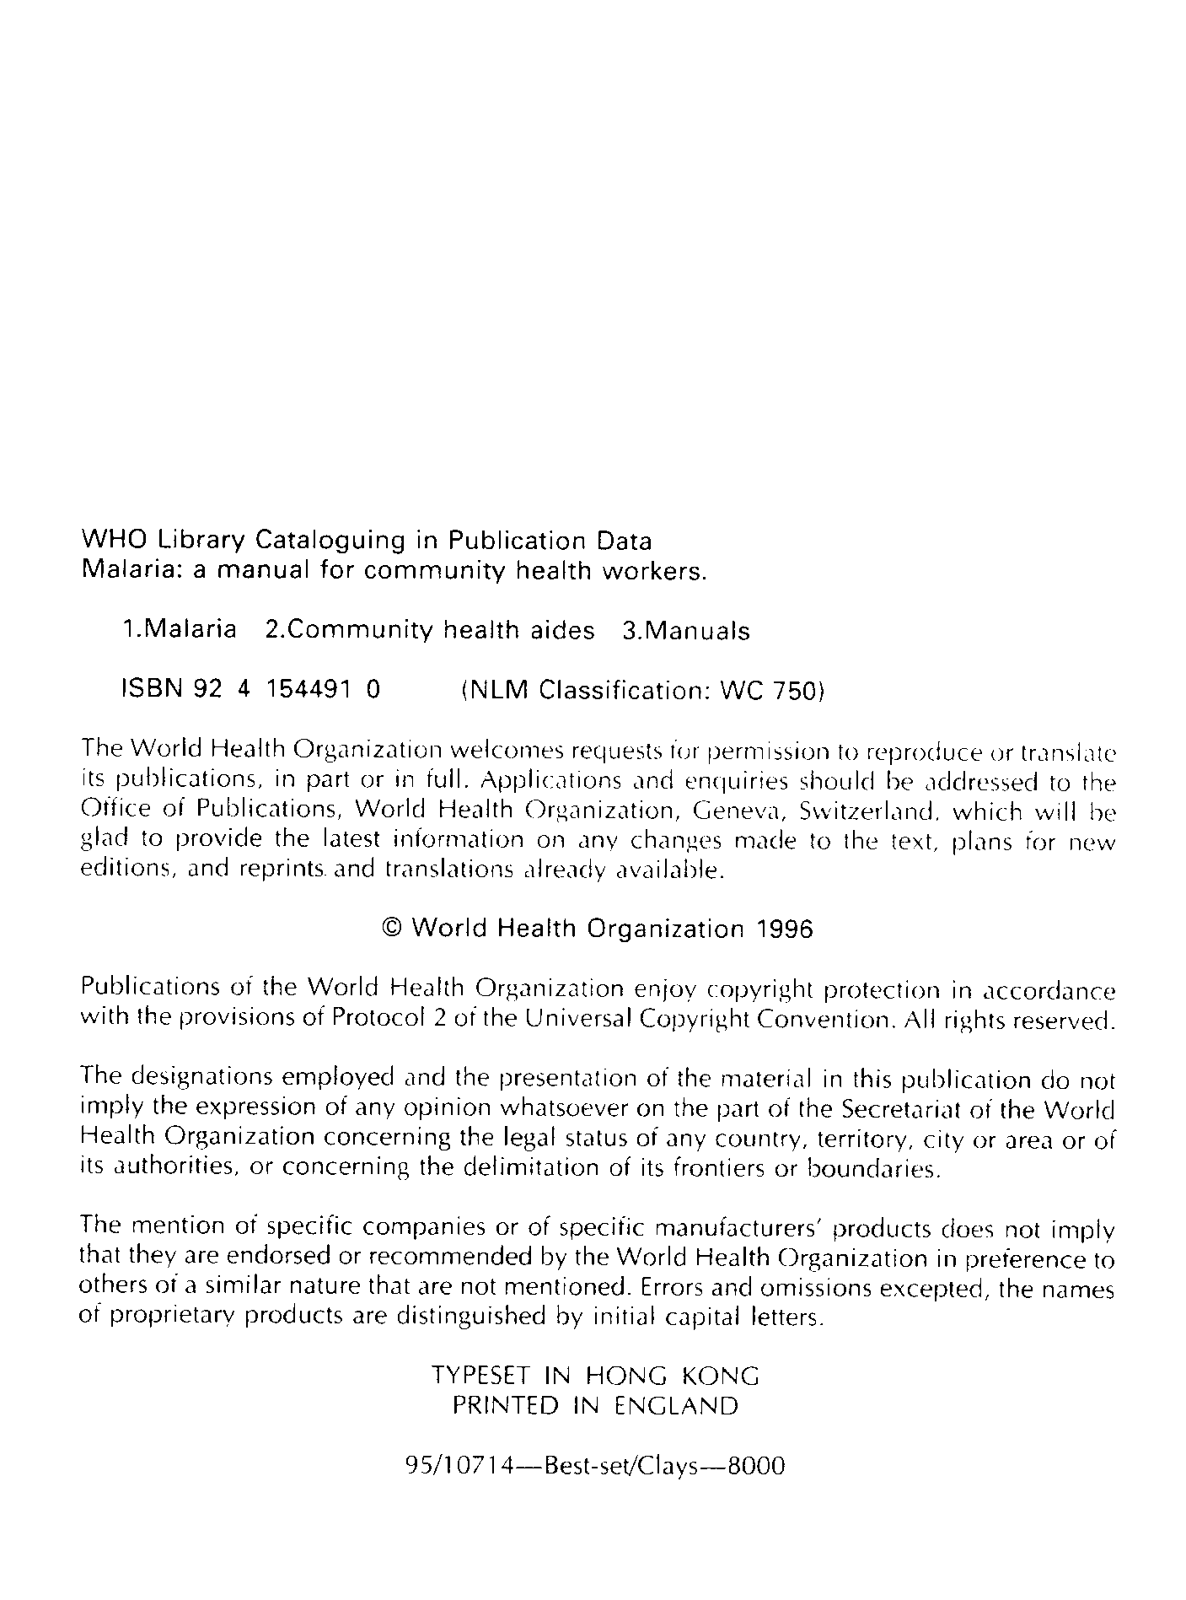
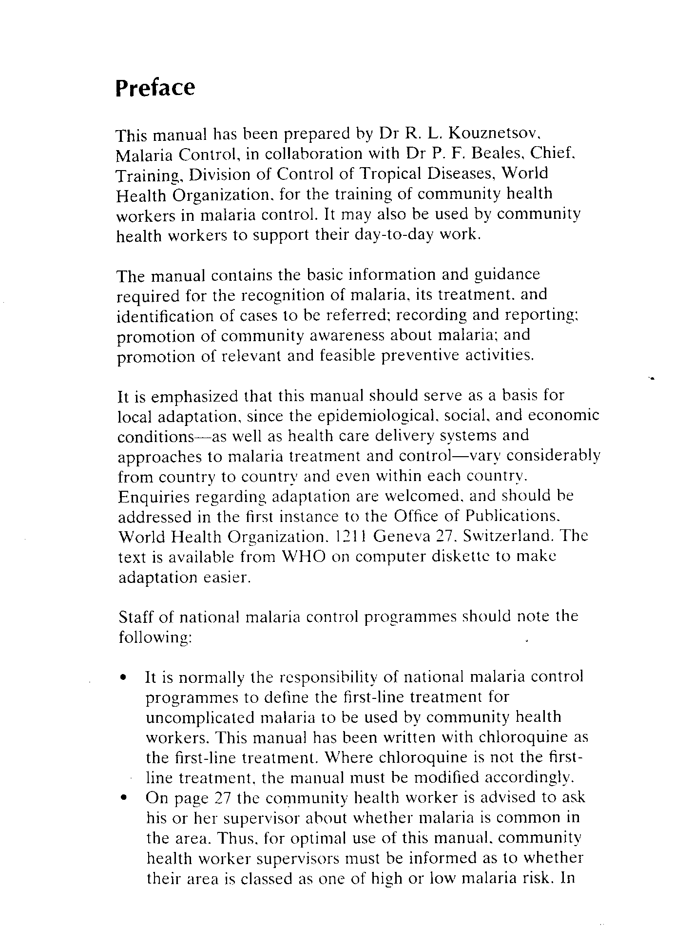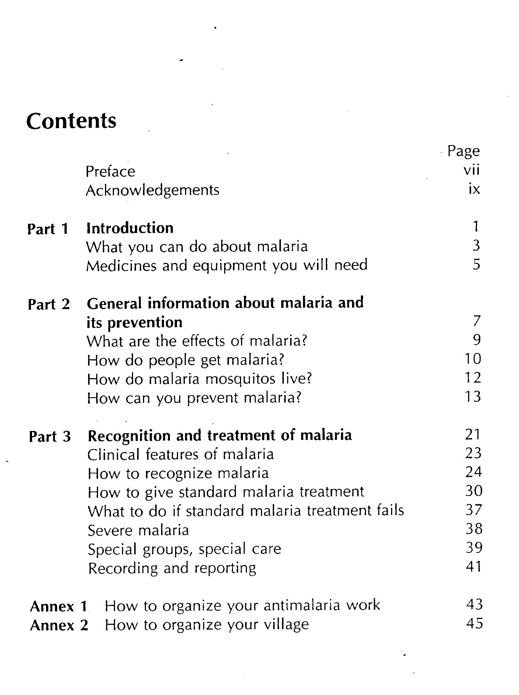

5.2 Developing a classification scheme

When developing a classification scheme, it is useful to work with members of the resource centre advisory committee (see Section 2.2) and/or other users, as these people will have a greater knowledge of the subjects to be covered by the resource centre.

5.2.1 How to develop a classification scheme
Start with a brainstorming session, to identify as many subject areas of interest as possible. Compare the list of subjects with subject areas identified by the most recent needs assessment (see Section 1.1) to make sure that none have been missed.

On your own, write each subject on a separate piece of paper. Arrange the pieces of paper in order, ranging from broad subjects to narrower subjects.

Diseases
Communicable diseases
Tuberculosis
HIV/AIDS
Parasitic diseases
Malaria
Non-communicable diseases
Diabetes
Place similar broad subjects near each other.
Women's health
Mother and child health
Reproductive and sexual health
Children and youth
When all the pieces of paper are arranged in a logical order, write down the order on a sheet of paper. Show it to the resource centre advisory committee or other users to obtain their agreement. Seeing the subjects in order will help them to notice if any subjects are missing.

Once the list of subjects has been agreed, write a classification number next to each subject. It is best if the classification numbers are made up of letters and numbers. It is easier to remember the letter(s) for a main class, combined with a number for a subsidiary class, than a long list of numbers. It also makes it easier to distinguish different classes on the shelf, both when looking for materials and re-shelving.

Do not automatically assign a full sequence of letters (ABCDE…) or numbers (12345…). It is important to leave gaps that can be used when new subjects are added, or when subject areas are expanded. The examples of the Healthlink Worldwide Classification Scheme in Section 5.2.3 show that there is plenty of room to add new classification numbers for main subjects, but little room for expanding the HC classification.

5.2.2 How to extend the classification scheme
If the resource centre collection expands into new subject areas (for example, emerging diseases such as hypertension), you may need to add new subjects to your classification scheme.

First, check the classification scheme carefully to make sure that there really is no suitable subject to describe the new material. Then find the most appropriate place in the list to add the new subject. Decide whether it is a main subject or a subsidiary subject, and add it next to the subject most similar to it. Give the new subject a classification number and description.

If possible, give a classification number that leaves room for further expansion. For example, in the Healthlink Worldwide Primary Health Care Classification Scheme subsidiary subject areas, the new subject, ‘Hypertension’ (a kind of cardiovascular disease) could easily be added after the subject ‘Cardiovascular diseases’ and assigned the classification number HC9.24 (see Section 5.2.3).

5.2.3 Healthlink Worldwide Primary Health Care Classification Scheme
Healthlink Worldwide compiled its own classification scheme in the mid-1980s. The scheme has been revised regularly to incorporate new subject areas covered by Healthlink Worldwide’s resource centre, reflecting emerging health issues.

The scheme covers the main subjects in primary health care and disability issues. Each main subject area is identified by two letters. For example, materials on diseases and disease control are identified by the letters HC. Each main subject area is divided into more specific, subsidiary subjects which are identified by numbers. For example, materials on immunisation are identified by HC3 and materials on non-communicable diseases are identified by HC9.

The Healthlink Worldwide Classification Scheme is used by many organisations, in either its original or an adapted form.

Main subject areas

AA POLITICS, ECONOMICS & DEVELOPMENT
AB Culture & Society
AD Population
AF NGOs

HA PRIMARY HEALTH CARE
HB Community Health Care
HC Diseases/Disease Control
HE Nutrition
HJ Medical Services
HK Medical Equipment & Health Facilities
HL Women's Health
HM Mother & Child Health
HN Reproductive Health & Sexual Health
HO Children & Youth
HP Traditional Health Care & Alternative Therapies
HQ Disability & Rehabilitation
HR Oral & Dental Health
HS Urban Health
HV Health Planning & Health Management
HW Health Services
HX Health Personnel & Training
HY Health Communication
HZ Regional Information

TA COMMUNITY DEVELOPMENT
TB Energy
TC Environment
TG Water & Sanitation
TH Food Production & Agriculture
TJ Gender & Development
TK Appropriate Technology
WA Information Services & Information Management

Subsidiary subject areas

HC DISEASES & DISEASE CONTROL

HC1 Diseases & Disease Control – general

HC2 Diagnosis & Management

HC3 Immunisation

HC4 Communicable diseases
HC4.2 tuberculosis
HC4.3 texually transmitted infections
HC4.4 HIV/AIDS

HC5 Diarrhoeal Diseases

HC6 Respiratory Diseases

HC7 Parasitic Diseases
HC7.2 malaria

HC8 Environmental Health & Occupational Health

HC9 Non-Communicable Diseases
HC9.1 cancer
HC9.2 cardiovascular diseases
HC9.3 congenital conditions
HC9.4 diabetes
HC9.7 rheumatism / arthritis

5.3 Assigning keywords

If the resource centre is very small, users will be able to find the materials they need by browsing (looking at) the shelves. Otherwise, the resource centre will need a card catalogue or computer database, which contains details of materials in the collection and indicates where to find them on the shelves. Information on databases is given in Section 6.8.

A system for describing the content of each material will need to be developed before details of materials can be included in a catalogue or computer database. The best way is to have a list of ‘keywords’, and describe each material using several keywords from the list. For example, the keywords used by Healthlink Worldwide’s resource centre to describe the book, Where there is no doctor, are:

community health care / traditional health care / community health workers / diagnosis / diseases / management & treatment

Keywords lists and thesauri (lists of terms used to describe different subjects) are called ‘controlled vocabulary’, because they specify which terms (words or short phrases) are used for describing materials. Most keywords lists also specify terms that are not used, and suggest terms to use instead.

5.3.1 Choosing a keywords list
Resource centres can develop their own keywords lists (see Section 5.3.3), or obtain and adapt standard keywords lists.

Both general and specialist lists are available. General lists include the Library of Congress Subject Headings and Sears’ Subject Headings. Specialist lists include the UNESCO Macro-thesaurus, National Library of Medicine Medical Subject Headings (MeSH), and Healthlink Worldwide’s Keywords List. Healthlink Worldwide’s list, which was originally compiled in the mid-1980s, is regularly revised to incorporate new subject areas reflecting emerging health issues. The list is used by many organisations in either its original or an adapted form.

5.3.2 How to assign keywords
To assign keywords, look at the material carefully to identify the main subjects covered. Do not rely on the title. For books and other print materials, look at the title page, list of contents and introduction. For audiovisual materials, look at the title, description and any accompanying materials, and by watching a video, listening to an audio cassette, or looking at slides.

Notice which sections or chapters are longest, or which may be of special interest to users of the resource centre. Then assign keywords.

Start with general terms and move on to more specific terms to describe the material’s subject matter. Use as many keywords as necessary. However, remember that users will expect to find useful information on the subjects indicated by keywords.

To choose keywords, consider:
- the main subject
- related subject(s)
- the group of people that the material describes, such as street children, women, community health workers
- potential target audience
- the focus or purpose, such as research, planning, evaluation or training.

If you are using a computer database, or have sufficient space for extra catalogue cards, you could also include keywords to indicate the type of language, such as technical or non-technical.

5.3.3 How to produce a keywords list
To produce a keywords list for your resource centre:

- List key terms (words or short phrases) that describe the main subject areas covered by the resource centre.

- Add terms that describe more general and less common subject areas.

- Explain any confusing terms in ‘scope notes’ (notes on the meaning of a keyword, and how it should be used).

- Add cross-reference notes (notes indicating additional keywords that could be used to describe related subjects, or keywords to use if the term is not a keyword).

You can see examples of scope notes and cross-reference notes in the sample of Healthlink Worldwide’s Keywords List in Section 5.3.4.

Getting things right with a ‘home-made’ keywords list is not always easy. You may need to add new terms to the list if you cannot find a term that describes the material that you are cataloguing.

When first developing a list, it is sensible to review the terms regularly. Once the list is established, review additions and possible changes about once a year.

5.3.4 Sample of Healthlink Worldwide Keywords List
The Healthlink Worldwide Keywords List is a list of all the terms used in the Healthlink Worldwide bibliographic database.

The list is divided into two columns. The left-hand column lists, in alphabetical order, the keywords to use (in bold capital letters) and terms not to be used as keywords (in lower case letters). The right-hand column shows keywords to use (in capital letters) instead of the terms that should not be used. It also includes notes on how and when to use keywords, and related keywords (in capital letters).

The notes next to ‘ACCESS’ are scope notes, explaining how to use the keyword. The notes next to ‘ACCIDENTS’ are cross-reference notes which refer to another, related keyword which could also be used if relevant. The notes next to 'adolescents' are cross-reference notes showing which keyword to use, since 'adolescents' is not a keyword.

ABORTION
ABSTINENCE
ACCESS use for physical accessibility for people with disabilities
ACCESSIBILITY use for accessibility of health care, services and facilities, see also UTILISATION or UTILISATION PATTERNS
accessibility patterns use ACCESSIBILITY and UTILISATION PATTERNS
ACCIDENTS see also TRAFFIC ACCIDENTS
ACTION LEARNING
ACUPUNCTURE
ACUTE RESPIRATORY INFECTIONS see also RESPIRATORY INFECTIONS
acute respiratory infections - incidence use ACUTE RESPIRATORY INFECTIONS and INCIDENCE
ACUTE RESPIRATORY INFECTIONS - LOWER see also PNEUMONIA
ACUTE RESPIRATORY INFECTIONS - UPPER see also OTITIS MEDIA or TONSILLITIS or WHEEZE
ADAPTATION OF SOCIETY
administration use DRUG ADMINISTRATION or HOSPITAL ADMINISTRATION or ORAL REHYDRATION THERAPY - ADMINISTRATION
adolescent health use YOUTH
adolescent pregnancy use TEENAGE MOTHERS
adolescents use YOUTH
ADOPTION
ADULT EDUCATION see also NON-FORMAL EDUCATION or FREIRIAN METHODOLOGY or LITERACY PROGRAMMES or WOMEN'S EDUCATION
ADULTS
ADVERSE EFFECTS use for side effects
advertising use MARKETING, see also DRUG MARKETING
ADVOCACY
AETIOLOGY see also VIRAL AETIOLOGY
aflatoxin use FOOD TOXINS
African trypanosomiasis use TRYPANOSOMIASIS
AGEING use for the ageing process and its relation to health, for older people, including ageing populations and health and community care of the elderly use ELDERLY

5.4 Cataloguing materials

Cataloguing is a way of describing materials to make them easy to identify and locate. A catalogue describing all the materials in a resource centre is like a key to the collection. It helps users to identify useful materials and know where to find them. Users can look at a catalogue to find out whether the resource centre has a particular publication, or materials by a particular author, or materials on a particular subject.

A catalogue contains the following information about each material:

- author  - title and sub-title  - edition  - series  - place of publication  - publisher | - date of publication  - number of pages and format  - illustrations  - subject (keywords)  - accession number  - classification number.
A catalogue can take various forms, such as a card catalogue (card index) or computer database (see Section 6). The easiest system is a card catalogue. Card catalogues are a series of cards, about 12.5cm by 7.5cm (5in by 3in) kept in a box. Card is used because it is stronger than paper, and is easy to write or type on. Card catalogues are inexpensive, easy to set up, easy to understand, and easy to keep up-to-date.

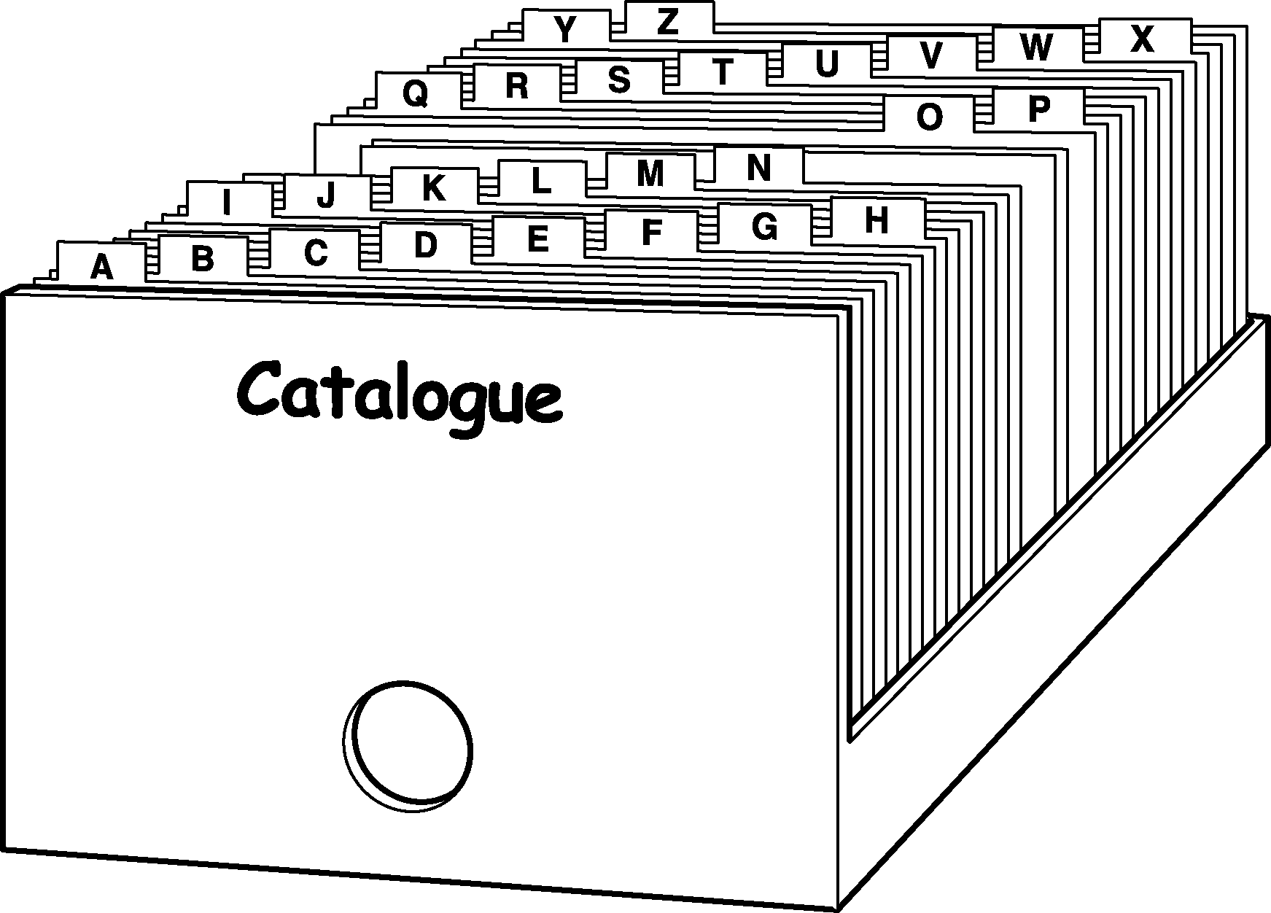

A simple card system is the easiest type of catalogue

5.4.1 Deciding what to catalogue
If the resource centre has only a small collection (fewer than 500 materials), materials need not be catalogued. It will be easy for users to find what they need by looking on the shelves, provided that materials are classified by subject, and materials on the same subjects are grouped together (see Section 5.1: Classifying materials). However, it may be useful to catalogue audiovisual materials, as they cannot be browsed like books. A short summary of the contents in a catalogue helps users to know whether an audiovisual material will be useful for a particular purpose.

It can also be useful to catalogue articles in periodicals, or individual chapters of books, that are of particular interest to users. Alternatively, photocopies could be taken of the contents page of the periodical issue, or of the title page and contents page of a book, in both cases marking the article or chapter of interest. The photocopies could be filed in a filing cabinet grouped by subject, or put in pamphlet boxes in the appropriate subject section on the shelves. It is also useful to keep an alphabetical list of periodical titles, to help users know what is available.

Even in a larger resource centre, not all materials need to be catalogued. Some materials are only of short-term interest, or quickly go out of date. These can be shelved or filed in a similar way to articles in periodicals. General reference materials may only need to be listed alphabetically, for example on a sheet of paper displayed near the materials.

5.4.2 How to catalogue materials
Catalogues of some larger libraries contain a lot of details. However, fewer details are enough for a resource centre that is more concerned with making materials available to users than spending a long time cataloguing and classifying.

Remember the tip: KIS - Keep It Simple.

For each material, details of the author, title, publication details, length, illustrations, notes, keywords, accession number and classification number need to be typed or written on three (or more) separate cards – an author card, title card and subject card(s). Each card will contain the same information, but with a different heading.

- The author card has a heading showing the author. If there is more than one author, extra author cards are prepared for up to three authors.

AGYEPONG, IRENE AKUA HC7.2 AGG

Agyepong, Irene Akua et al.
The malaria manual : guidelines for rapid assessment of
social, economic and cultural aspects of malaria

(Methods of Social Research in Tropical Disease No.2)

Geneva : UNDP, 1995

170 pages

malaria / guidelines / rapid assessment procedures 17615

- The title card has a heading showing the first part of the title.

MALARIA MANUAL HC7.2 AGG

Agyepong, Irene Akua et al.

The malaria manual : guidelines for rapid assessment of
social, economic and cultural aspects of malaria

(Methods of Social Research in Tropical Diseases No. 2)

Geneva : UNDP, 1995

170 pages

malaria / guidelines / rapid assessment procedures 17615

- The subject card has a heading showing a keyword. If more than one keyword is used to describe the material, extra subject cards are prepared for each keyword.

MALARIA HC7.2 AGG

Agyepong, Irene Akua et al.

The malaria manual : guidelines for rapid assessment of
social, economic and cultural aspects of malaria

(Methods of Social Research in Tropical Diseases No. 2)

Geneva : UNDP, 1995

170 pages

malaria / guidelines / rapid assessment procedures 17615

Start by finding all the information you need about each material. Then decide how many cards you need. Type or write all the necessary information on each card, and then add the relevant author, title or subject heading at the top. To arrange the information on the card, see Section 5.4.3: Examples of catalogue cards.

For books and other print materials, find the information you need by looking at both sides of the title page. The title page is at the front of the book, but is not always the first page. It contains information about the book. The other side of the title page usually contains details of the publisher, and publication date (see illustration in Section 5.1.2).

For audiovisual materials, look at the video title frames, the video or audio cassette, the information printed on the cassette boxes, and any accompanying material.

1. Author information
a) Look for the author (or editor or compiler).

b) Write the family name first, then the first name, separated by a comma.
Example: NGECHU, Mary

c) If the material has two or three authors, list all the authors’ names. Separate the names with a space, semi-colon and another space.
Example: LANKASTER, Ted ; CAMPBELL, Ian D ; RADER, Alison
Make extra cards with headings for the second and third names.

d) If the material has more than three authors, use the first name only, followed by the words ‘et al’ (which mean ‘and others’ in Latin).
Example: AGYEPONG, Irene Akua et al.

e) If the material has an editor or compiler instead of an author, treat the editor or compiler as the author, but add ‘Ed.’ or ‘Comp.’ in brackets.
Example: Dhingra, Seema (Ed.)

f) If the author is an organisation, write the name in full.
Example: World Health Organization

2. Title information
a) Look at the title page and back of the title page. The title here might not be exactly the same as the title on the front cover. Sometimes the title on the front cover is abbreviated, and the sub-title is not shown. Write out the title in full. If there is a sub-title, write this out, separated by a colon with a space before and after. The spaces help to emphasise that the following text is a sub-title. A colon without a space can be easily missed, or could be seen as part of the text.
Example:
The malaria manual : guidelines for rapid assessment of social, economic and cultural aspects of malaria

b) If the material is not a printed publication, note its format in square brackets after the title.
Examples: [Braille] [Audio cassette] [CD-ROM] [Video]

c) If the material is a second or third edition, write this in abbreviated form after the title, separated by a full stop, space, dash and another space. This punctuation helps the information to be easily identified.
Example: On being in charge. – 2nd Ed.

- Series information
If the item is part of a series, write the series in brackets after the title.
Example:
The malaria manual : guidelines for rapid assessment of social, economic and cultural aspects of malaria (Methods of Social Research on Tropical Diseases No. 2)

4. Publication details
a) Publication details include the place of publication, publisher's name and date of publication. These are usually found at the bottom of the title page or on the back of the title page. Separate the place and publisher with a space, a colon and another space, and separate the publisher and date of publication with a comma.
Example: London : Macmillan, 1994

b) Place of publication Usually only the town needs to be written, but write the country as well if it would not be obvious to your users. If several towns are listed, write the first one only. If no place has been given, write in square brackets: [place unknown].

c) Publisher The publisher's name follows the place of publication. Write the publisher's name in the shortest form. If the publisher is the same as the author or editor, use an abbreviation. Separate the place of publication and the publisher with a space, a colon and another space.
Example: Geneva : WHO, 1996
If there is no publisher, write in square brackets: [publisher unknown].

d) Date of publication This follows the publisher's name. It is usually sufficient to give the year. For project papers and reports, include the month as well, if given.
If no date is given, but is known, write the date in square brackets.
Example: [1999]
Otherwise, try to estimate the date from information given in the publication, and use a question mark.
Example: [1998?]

5. Number of pages/format/length
a) Write down the number of pages followed by 'p.'
Example: 145 p.
If there are no page numbers, estimate the number, and put this in square brackets.
Example: [150 p.]

b) To catalogue Braille materials, write down the number of pages or leaves (if only one side of the page can be read), depending on the type of Braille used in the publication.
Example: 34 leaves

c) To catalogue audiovisual materials, write down the format, and then the length in brackets. If the length is not shown, time the tape when playing. It is not necessary to watch or listen to the whole tape, only to note the time when it starts and ends.
Example: Audio cassette (35 min.)

If audiovisual materials are accompanied by an information sheet, a trainer's guide, or a booklet, this should be mentioned in the catalogue. Separate this from the format and length information with a space, plus sign and another space.
Example: Audio cassette (35 min.) + booklet (23 p.)

6. Illustrations
It is often helpful for users to know whether a material contains illustrations, before they start looking for the material on the shelves. If print materials contain any illustrations that are important for understanding the material, this should be mentioned in the catalogue. You can do this by adding the abbreviation ‘ill.’ after the number of pages or length, separated by a space, semi-colon and another space.
Example: 23 p. : ill.

7. Notes
Put any notes needed to explain the content of the material.
Example: Tape and booklet to accompany the Healthy Woman Counselling Guide radio programme

8. Keywords
Write the keywords, separated by a forward slash. Use enough keywords to describe the content of the material.
Example: malaria / health education / radio

9. Accession number
Write the accession number at the bottom right-hand corner.

10. Classification number
Write the classification number at the top right-hand corner.

5.4.3 Examples of catalogue cards

Author catalogue
Authors can include both individuals and institutions, and for the purposes of cataloguing, they can also include editors, compilers, video producers, performers and others with some intellectual or artistic responsibility for the material.

Author catalogues list materials according to the family name or last name of the author, if the author is an individual.
NGECHU, Mary HC7.2 NGE

Ngechu, Mary

Small insects, big trouble [Audio cassette].

Geneva : WHO, 1996

Audio cassette (35 min.) + booklet (23 p.)

Tape and booklet to accompany the Healthy Woman Counselling Guide radio programme

malaria / health education / radio 13577
WORLD HEALTH ORGANIZATION HC7.2 WOR

World Health Organization

Malaria : a manual for community health workers

Geneva : WHO, 1996

46 pages

malaria / community health workers

13572

The author heading is in capital letters to identify it as a heading, and a separate card is made out for each author listed.
GORDON, Andrew

Gordon, Andrew

Vector-borne diseases : a short list for community participation. p. 1-2
In : Voices from the City Vol. 7
Sept 96

Parasitic diseases / malaria / dengue /
prevention and control / community participation
13576

AGYEPONG, IRENE AKUA HC7.2 AGG

Agyepong, Irene Akua et al.

The malaria manual : guidelines for rapid assessment of social, economic and cultural aspects of malaria

(Methods of Social Research in Tropical Diseases No. 2)

Geneva : UNDP, 1995

170 pages

malaria / guidelines / rapid assessment procedures 17615

Title catalogues
Title catalogues list materials according to the title of the material.

The title heading is in capital letters to identify it as a heading. Only include as much of the title as will fit on one line. Do not include sub-titles.

MALARIA MANUAL HC7.2 AGG

Agyepong, Irene Akua et al.

The malaria manual : guidelines for rapid assessment of social, economic and cultural aspects of malaria

(Methods of Social Research in Tropical Diseases No. 2)

Geneva : UNDP, 1995

170 pages

malaria / guidelines / rapid assessment procedures17615
MALARIA HC7.2 WOR

World Health Organization

Malaria : a manual for community health workers

Geneva : WHO, 1996

46 pages

malaria / community health workers 13572
SMALL INSECTS, BIG TROUBLE HC7.2 NGE

Ngechu, Mary

Small insects, big trouble [Audio cassette].

Geneva : WHO, 1996

Audiocassette (35 min.) + booklet (23 p.)

Tape and booklet to accompany the Healthy Woman Counselling Guide radio programme

malaria / health education / radio 13577

VECTOR-BORNE DISEASES

Gordon, Andrew

Vector-borne diseases : a short list for community participation. p. 1-2
In : Voices from the City Vol. 7 Sept 96

parasitic diseases / malaria / dengue /
prevention and control / community participation

13576

Subject catalogues
Subject catalogues list materials according to the keywords listed on the catalogue cards.

The subject heading is in capital letters to identify it as a heading. A separate card is made out for each subject listed.
MALARIA HC7.2 NGE

Ngechu, Mary

Small insects, big trouble [Audio cassette].

Geneva : WHO, 1996

Audio cassette (35 min.) + booklet (23 p.)

Tape and booklet to accompany the Healthy Woman Counselling Guide radio programme
malaria / health education / radio 13577

MALARIA HC7.2 AGG

Agyepong, Irene Akua et al.

The malaria manual : guidelines for rapid assessment of social, economic and cultural aspects of malaria

(Methods of Social Research in Tropical Diseases No. 2)

Geneva : UNDP, 1995

170 pages

malaria / guidelines / rapid assessment procedures17615
MALARIA HC7.2 WOR

World Health Organization

Malaria : a manual for community health workers

Geneva : WHO, 1996

46 pages

malaria / community health workers

13572
PARASITIC DISEASES

Gordon, Andrew

Vector-borne diseases : a short list for community participation. p. 1-2
In: Voices from the City Vol. 7 Sept 96

Parasitic diseases / malaria / dengue /
prevention and control / community participation

13576

5.4.4 Filing catalogue cards
Catalogue cards need to be filed in a way that makes them easy to use. There are three different ways of filing catalogue cards. They can be filed as three separate catalogues in three separate boxes (Author, Title and Subject), or as two catalogues (Author/Title and Subject), or as a single ‘dictionary catalogue’ in which they are all filed together in alphabetical order, such as:

MacDonald, James (author)
McKenzie, R (author)
Malaria (subject)
Malaria Manual (title)
Measles (subject)
Ngechu, Mary (author)

Examples of different ways to file catalogue cards are shown on the next page.

Standard rules need to be followed when filing cards:
- English: Ignore A, An and The at the beginning of a title.
- French: Ignore La, L', Le, Les, Un and Une at the beginning of a title.
- Portuguese: Ignore A, O, Um and Uma at the beginning of a title.
- For books by the same author, file cards alphabetically by title.
- For books with more than one edition, file cards for the most recent edition first.
- For books on the same subject, file cards alphabetically by author, and then by title as above.

Examples of different ways to file catalogue cards

Author catalogue Title catalogue Subject catalogue

WORLD HEALTH ORGANIZATION
VECTOR-BORNE DISEASES

PARASITIC DISEASES
NGECHU, Mary

SMALL INSECTS, BIG TROUBLE

MALARIA

GORDON, Andrew

Vector-borne diseases : a short list for community participation

MALARIA

World Health Organization
Malaria : a manual for community health workers

MALARIA

AGYEPONG, Irene Akua et al. The malaria manual : guidelines for rapid assessment of social and economic aspects of malaria

Dictionary catalogue

WORLD HEALTH ORGANIZATION

SMALL INSECTS, BIG TROUBLE
PARASITIC DISEASES

NGECHU, MARY
MALARIA

GORDON, ANDREW

Gordon, Andrew
Vector-borne diseases : a short list for community participation

WORLD HEALTH ORGANIZATION

Implementation of a global malaria
Control
SMALL INSECTS, BIG TROUBLE

Nechu, Mary
MALARIA

World Health Organization
Malaria : a manual for community health workers
Geneva : UNDP, 1996

MALARIA

Nchue, Mary
Muucoore my friend : small
PARASITIC DISEASES

Gordon, Andrew
Vector-borne diseases : a short list for community participation.
WORLD HEALTH ORGANIZATION
SMALL INSECTS, BIG TROUBLE
PARASITIC DISEASES
NGECHU, MARY
GORDON, ANDREW

Gordon, Andrew
Vector-borne diseases : a short list for community participation.

5.5 Shelving, displaying and filing materials

Once materials have been classified and catalogued, they are ready to be put on shelves, on display, or in files in the resource centre.

5.5.1 Shelving materials
Shelving means arranging materials on shelves according to their classification number. Materials on the same subject have the same classification number, so they are arranged together alphabetically by the first three letters of the author’s name, or by title if no author is given.

Good shelving:
- makes it is easy for users to find what they need
- makes it easy for staff to do a stock check
- helps staff to answer queries.

It is very important to ensure that each material is put in the right place. If books have been mixed up, they must be rearranged in the correct order. This is called ‘shelf reading’, and needs to be done regularly.

Book supports are useful to ensure that books stay upright (see Section 3.3: Choosing furniture and equipment).
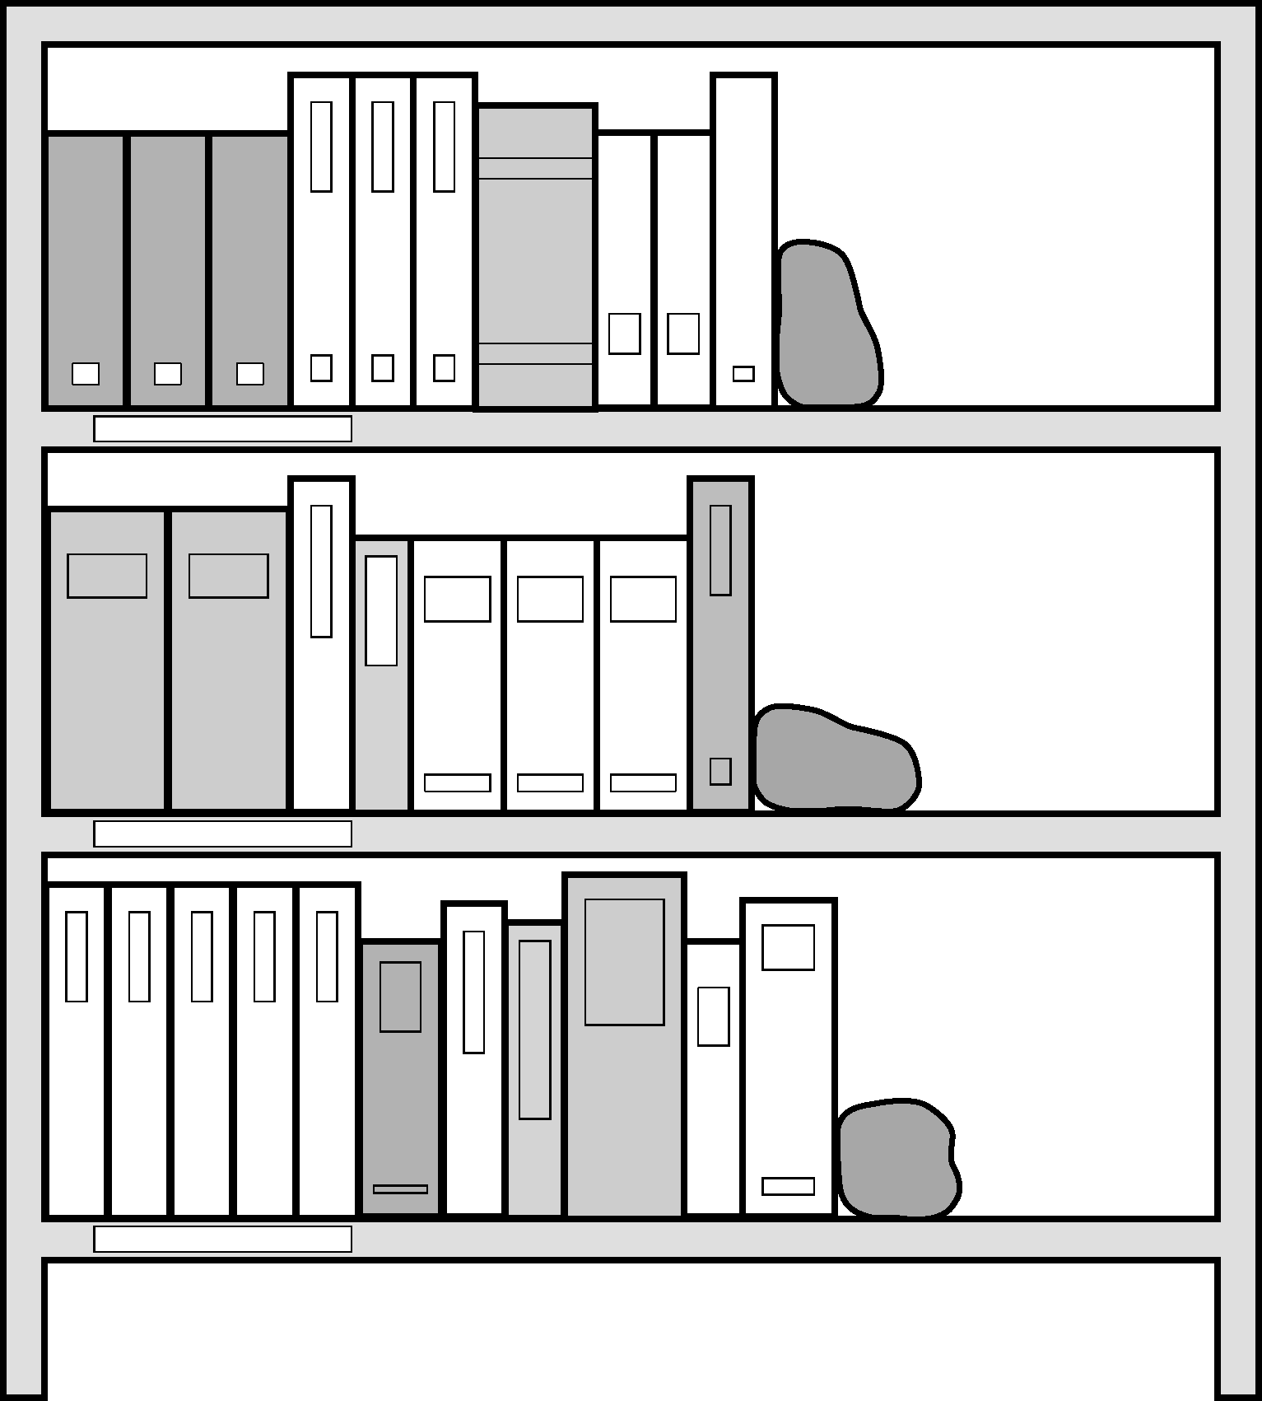

It is best not to overcrowd shelves

Books and documents Books should be arranged upright from left to right, starting on the top shelf. Shelves must not be overcrowded. Overcrowding can damage the books by preventing any flow of air between them and making it awkward to remove them. It will also leave little space for adding new books. It is best to fill only three-quarters of the shelf space to allow for new additions. This will save staff from constantly having to move books to make room for new ones.

Each shelf should be labelled according to its subject, so that users can see where to find material on a particular subject. If shelves are labelled with classification numbers and the subject that they represent, it will help users to understand the classification system.

Shelf labels or book labels can also be used to identify different categories of materials. For example, different coloured labels can be used to identify materials that may not be borrowed, or to distinguish training manuals from other publications.

Labels can be hand-made and stuck onto the shelves, or a special shelf-label holder can be obtained from library suppliers.
TIP: How to make shelf labels
You can make shelf labels from stiff white or coloured cardboard. The piece of card should be long enough to fit the number of letters needed, without making the letters too small to see from a distance. The height of the card should be no more than a couple of inches, to prevent it getting in the way of removing books from the shelf.

Write the classification number and subject on the piece of card clearly with a thick, felt-tip pen. If you have a computer, print the labels in large type. If possible, cover the labels with transparent tape to keep them clean and protect them from damage.
Oversized books, posters and audiovisuals It is often convenient to keep very large books separately from other books, as this makes better use of shelving space, and enables more materials to be fitted into a smaller resource centre.

Slides are sometimes kept in hanging files, either in filing cabinets or filing boxes. Posters are usually stored in map chests or plan chests, or in a large folder (see Section 3.3: Choosing furniture and equipment). Rolling up or folding posters is not recommended, as it may damage them.

Videos are sometimes kept in a locked cupboard. If so, it is very important to provide a list of videos in subject order, with brief summaries of their content, so that users know what is available.

Periodicals Periodicals are best kept in pamphlet boxes or magazine boxes (see Section 3.3.3). These help to protect the periodicals and make them easily accessible. All parts of a periodical volume should be kept in one box. Several periodicals can be kept in the same box, to save space. Each box should be clearly labelled with the title of the periodicals in it, and the years of publication and volume numbers. Issues of each periodical should be arranged in the order of their volume and issue number, starting with the first volume and issue number and continuing to the most recent.

There are two choices about where to keep periodicals. They can either be kept together in a separate section of the resource centre, arranged by title, or they can be put on the shelves (in pamphlet boxes) with books and other materials on the same subject. Keeping periodicals with books can help to bring them to the attention of users who are interested in a range of materials on a particular subject. However, a separate section may also be needed for periodicals that cover a wide range of subjects.

If funds are available, it might be worth having complete volumes of periodicals bound. However, before doing this, it is important to consider how long each periodical will be kept, and how often it will be used. For example, news magazines are useful for a shorter period than other periodicals containing less time-specific information. Instead of keeping the whole periodical, useful articles could be catalogued and kept in a filing cabinet.

5.5.3 Filing materials
It is important to keep materials such as leaflets, brochures and annual reports in a way that makes them easy to find. These materials can kept either on the shelves (in pamphlet boxes) with books and other materials on the same subject, or in filing cabinets, filed by subject or organisation name, depending on how the information is most likely to be sought. If there are a lot of materials, such as leaflets about many different organisations, they could be filed first by geographical area and then by organisation name.

5.5.4 Displaying materials
There are a number of reasons for displaying materials in a resource centre. Displays help to highlight new materials, and encourage people to use them. An attractive display adds colour and interest to the resource centre, and shows that staff are actively providing a good service.

New books, periodicals or other materials should be displayed in a ‘display area’ of the resource centre for between a week and a month (depending on how often new materials arrive), so that users can see them before they are put on the shelves. Details of new materials should be included on noticeboards elsewhere in the organisation, to promote them to those who do not visit the resource centre regularly (see Section 8.2: Promoting the resource centre).

Current issues of periodicals are usually displayed on display racks, arranged alphabetically by title. Each time a new issue arrives, the previous issue should be removed and put in the appropriate pamphlet box.

