Section 4: Developing the collection

It is important to collect only materials that will be useful. Materials that are not relevant to users, or that are badly written or translated, are a waste of time and space. The collection needs to be balanced in terms of subject areas and formats, to meet the needs of all users, not just some.

This section includes:
4.1 Developing a collection policy
4.2 Format of materials
4.3 Sources of materials
4.4 Selecting materials
4.5 Obtaining materials
4.6 Receiving materials
4.7 Updating the collection
4.8 Sample letters
4.9 List of distributors

Related sections include:
1.1 Assessing information needs
2.2 Advisory committees
  - Financial planning
7 Information services

4.1 Developing a collection policy

Every resource centre needs a collection policy to ensure that:
- the collection is useful for the people who use the resource centre
- financial and other resources are used well
- the collection does not duplicate other collections that are accessible to users.

Developing the collection policy is the responsibility of the resource centre officer. However, the policy needs to be developed in consultation with the resource centre officer’s manager or supervisor and the resource centre advisory committee (if there is one) and/or other users. The policy needs to be reviewed and updated about every two years.

4.1.1 How to develop a collection policy
Start by looking at the overall aims of the resource centre and the needs of existing and potential users (see Section 1.1). Write down the subject areas that are most important. Write down other relevant subject areas. Write down what format of materials and reading level is required for different users of the resource centre. Ask the resource centre advisory committee (if there is one) to help you with all this.

Identify other resource centres that have collections on these subject areas, and consider whether users have access to them. If not, consider whether you can establish a good relationship with any of these resource centres, which might include supplying or lending materials.

Decide and write down how long particular materials should be kept, including issues of periodicals, and when to weed out (remove) materials that should no longer be kept.

This information forms the collection policy. Use the collection policy to help you decide which materials to add to the collection and which to remove.

4.2 Format of materials

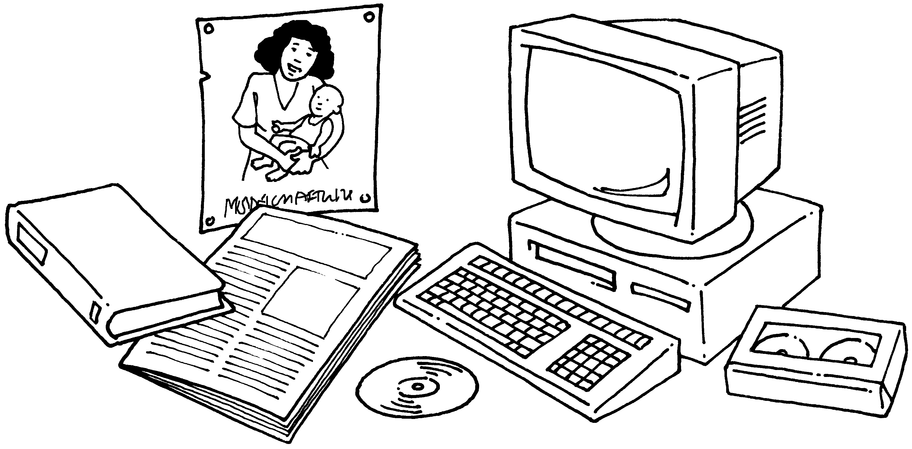

There are many types of information materials

Materials are available in an increasing range of formats. There are four main groups:
- printed materials
- display materials
- audiovisuals
- electronic materials.
Information is also communicated in a variety of other ways.

Printed materials (including Braille materials) are produced by a printing press, computer printer, or photocopier. They include: books, educational pamphlets, government guidelines, handouts, newsletters, organisational reports and other documents, resource lists, research reports, study guides and training materials.

Display materials can be shown without the use of equipment such as a projector. They include: biological specimens, flipchart displays, magnetic or chalkboard displays, photographs, posters, models, flannelgraphs and wallcharts.

Audiovisual materials need equipment to be used. They include: audio cassettes, overhead projector transparencies (OHPs), slides and videos.

Electronic materials need a computer to be shown or used. They include computer-assisted learning (CAL) materials, CD-ROM, interactive video discs, and information available via e-mail and the Internet.
Other ways of communicating information include:
- songs
- plays
- proverbs
- conversations with colleagues
- meetings
- workshops
- contact with individuals or groups around similar subject interests – this is often called networking.

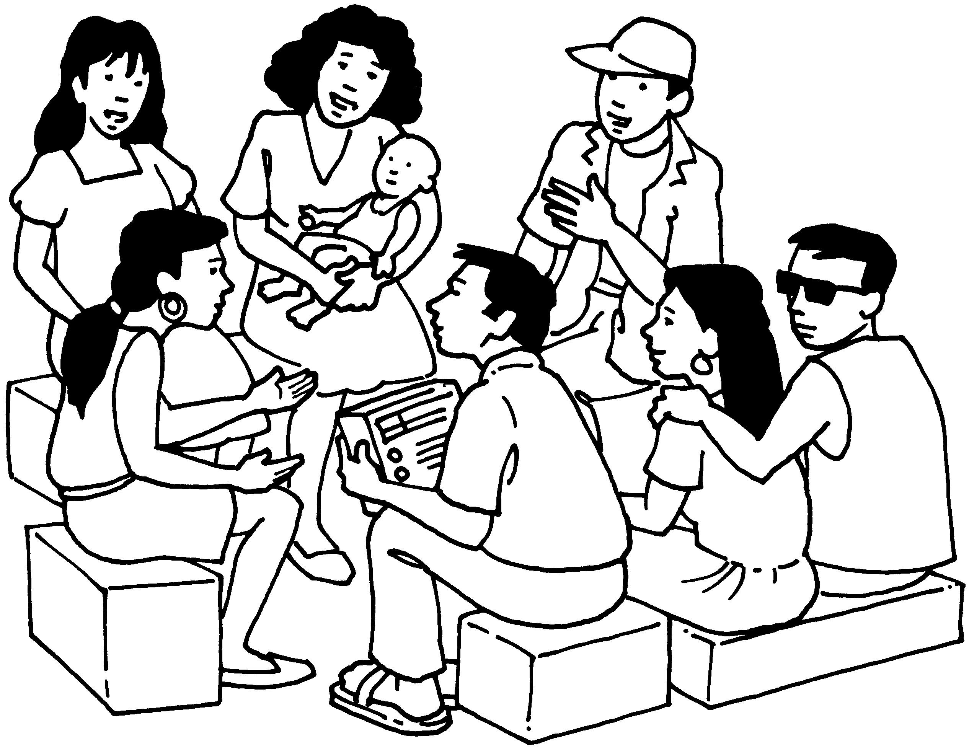
In many settings, these less formal methods of communication are the primary way in which information is communicated. Integrating less formal methods of communication into the work of a resource centre can often improve its use and its impact.

4.3 Sources of materials

A wide range of sources can be used to find out what materials are available. The main sources are:
- producers and distributors
- bibliographic sources
- local information sources
- the Internet.

TIP: Developing contacts
It is a good idea to develop contacts with local, national and international organisations that produce or disseminate information that may be of use to users. Book fairs and exhibitions are a good place to develop contacts. Details of organisations should be kept on file. Organisations should be contacted, asking to be put on their mailing list to receive regular information about new materials.

4.3.1 Producers and distributors
Producers and distributors include:
- specialist suppliers
- commercial publishers
- United Nations agencies
- government departments
- non-governmental organisations (NGOs)
- professional associations
- training institutions
- subscription agents.

Specialist suppliers, such as the African Books Collective, Hesperian Foundation, IT Publications, PACT, Tropical Health Technology and Teaching-aids at Low Cost (TALC), supply materials to developing countries, usually at lower prices than commercial publishers. Suppliers' catalogues are available free on request.

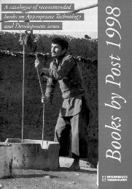
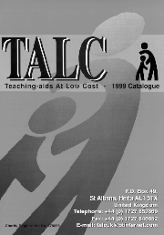
Commercial publishers are organisations that produce materials for profit. Commercial publishers that produce materials on health and development include Butterworth-Heinemann, Macmillan, Oxford University Press (OUP) and Zed Books. Some of the larger publishers, such as Macmillan and OUP, have offices in developing countries, which support local production and distribution of materials. Publishers’ catalogues are available free on request.
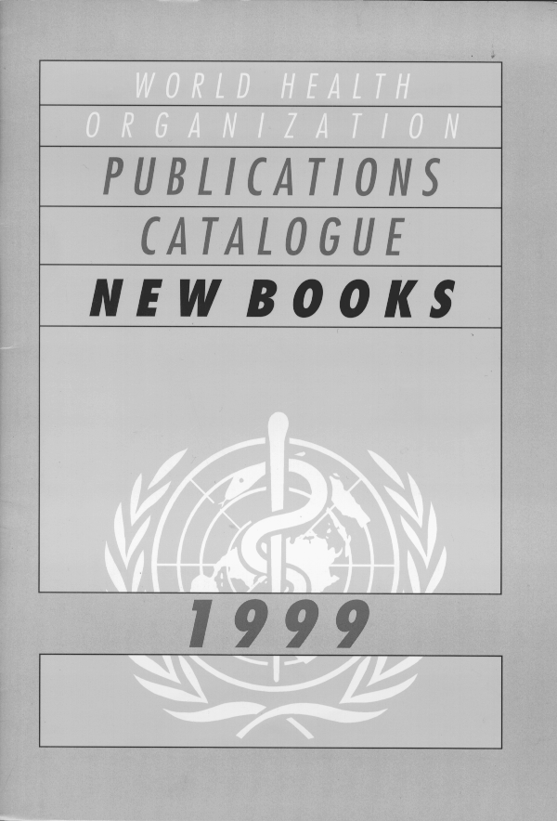
Most United Nations agencies, such as UNESCO, UNICEF, UNDP, WHO and the World Bank, and NGOs, such as AMREF, Healthlink Worldwide, INTRAC, International Planned Parenthood Federation (IPPF), Oxfam, Save the Children (SCF) and Women INK, produce materials, often free or at low cost. Most produce catalogues or publications lists that are available free on request. Government documents from ministries such as the Ministry of Health include important policy documents, guidelines and training manuals.

Professional associations of, for example, doctors, nurses or librarians, produce materials including books, guidelines and newsletters.

Training institutions may produce training materials, including distance education materials.

Subscription agents, such as Swets Blackwell, organise subscriptions to periodicals.

Details of key producers and distributors of materials are given in Section 4.9.

4.3.2 Bibliographic sources
Bibliographic sources include:
- resource lists and bibliographies
- bibliographic databases
- acquisitions bulletins
- book reviews and summaries
- sources of information for articles
- Blue Trunk Library lists.

Some publications are a combination of different types of material providing bibliographic source information.

Resource lists are publications that contain details of materials, usually on a specific subject such as diarrhoeal diseases, disability issues, or reproductive and sexual health. They usually include a brief description of each material, the price, and details of how to obtain the material.

Bibliographies are similar to resource lists, but do not necessarily include information on how to obtain materials. Resource lists and bibliographies are usually available in print or electronic format.

Bibliographic databases contain bibliographic information on computer about publications or articles in periodicals, including the author, title, publisher and price. They use keywords (selected words or phrases) to describe the content. Some include abstracts (summaries of contents). Others include the full text of articles. Many bibliographic databases are available on CD-ROM, the Internet or on-line information services. Bibliographic databases containing details of materials on health and development include African HealthLine, African Index Medicus, CAB Health, Extramed, Source, Medline, and POPLINE.

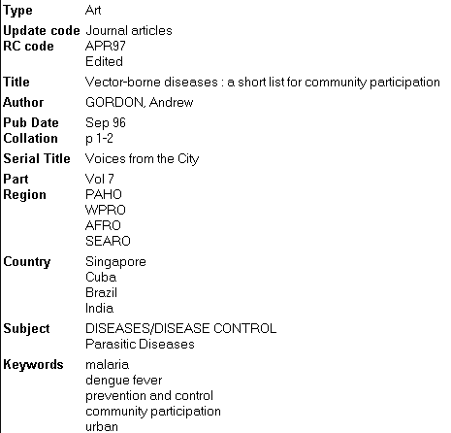

Example of a bibliographic database record

Acquisitions bulletins are regular publications that contain details of materials added to a resource centre collection during a particular period. They can be used to find out what has been acquired by other resource centres, and to help identify materials for the collection. The resource centre can either subscribe to an acquisitions bulletin or, if it produces one, it can arrange to receive others in exchange.

Book reviews and abstracts (summaries) in newsletters, magazines and journals can help to assess whether a material will be useful. They often comment on the material, as well as describing the contents. It can be useful to photocopy and file reviews to help select materials. Reviews can also be circulated to users.

Sources of information for articles in newsletters, magazines and journals are often listed at the end of the article. They can be used to identify materials for the collection. However, the materials listed are usually not new, and are more useful for building up a collection in a new subject area than updating an existing subject area.
Blue Trunk Libraries list, produced by the World Health Organization (WHO) Library and Information Networks for Knowledge Programme, lists about 150 publications selected for their Blue Trunk Libraries project. The materials are divided into 14 categories: General medicine and nursing, Community health, Primary health care, Health management and epidemiology, Maternal health and family planning, Child health, Diarrhoeal diseases, Nutrition and nutritional disorders, Essential drugs, Communicable diseases and vaccination, Parasitic diseases and vector control, Sexually transmitted diseases and AIDS, Surgery, anaesthesia and hospitals, and Medical and laboratory technology. See
http://www.who.int/library/country/trunks/contents/index.en.shtml

4.3.3 Local information sources
Local sources of information include:
- colleagues in the same organisation
- resource centre users
- other organisations
- research and development projects
- training programmes
- book fairs, exhibitions and conferences.

Colleagues and users of the resource centre are useful sources of information about materials for the collection. They can be asked to suggest materials. For example, they might recommend a manual that they have used during a training workshop, or that has been recommended by another colleague. Members of the resource centre advisory committee (see Section 2.2) should be involved in deciding what to collect, and it is worth encouraging them to suggest ideas.

Other organisations working in similar areas can also be useful sources of information. Resource centre staff may be in touch with staff of other resource centres, or with staff of organisations working in a similar subject area.

Research and development projects, being carried out either within the same organisation as the resource centre or elsewhere, are a source of information on new developments and findings.

Training programmes usually provide participants with handouts, photocopies of sections of materials and reading lists. These materials may themselves be useful additions to the collection, or they may help to identify useful materials. It is therefore good to encourage people to share such materials with resource centre staff.

Book fairs, exhibitions and conferences include displays by publishers and booksellers of new materials.

4.3.4 The Internet
If the resource centre has a computer connected to the Internet, information sources such as electronic conferences or discussion groups and on-line databases will also be accessible. Full-text documents on the Internet can be obtained by resource centres with only e-mail access. They are often advertised on newsletters or through electronic discussion lists. See Section 6.5 for information about Internet services.

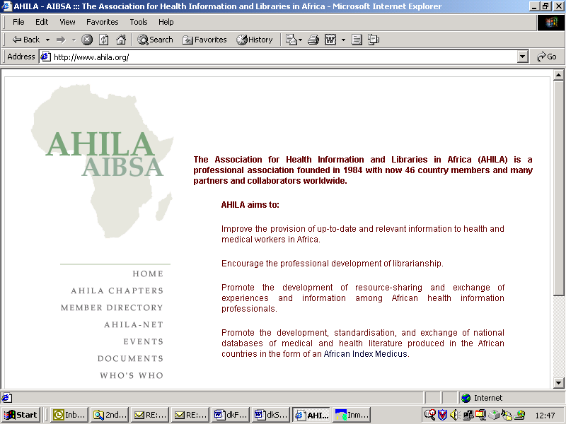

Example of a web page

4.4 Selecting materials

The collection policy (see Section 4.1), which is based on an analysis of users’ needs, should be used to help select materials. A range of materials including books, newsletters and videos should be collected, according to the needs of users. Information about other organisations working in related areas should also be collected. It is important to keep in regular contact with other organisations that provide information services.

Selecting materials requires a good knowledge of the existing collection, the subject area, and users’ needs. If the resource centre has an advisory committee representing users, selection of new materials should be discussed and agreed with the committee. Other staff and users should pass suggestions to the resource centre officer, who can present them to the committee.

4.4.1 How to select materials
To decide whether to add a particular book, video, article or other material to the collection, ask yourself:

- What is the content? If you have a copy of the material, look at the contents page if it is a publication, or summary information if it is a cassette, etc. If you are using a resource list, look at the list of keywords. The title does not always give a clear indication of what the material contains.

- Who is the material for? If you have a copy of the material, look at the foreword or introduction, summary information if it is a cassette, or accompanying description. If you are using a resource list, look at the description of the material. Decide whether the material is intended for the people your resource centre is serving. For example, an academic textbook on drug abuse would not be useful for a nurse who wanted practical information about drug abuse for health education work in a secondary school. Similarly, a video on disabled people’s rights which was filmed in Africa might not be useful for an Asian audience.

- Is the information accurate and up-to-date? Look at the date of publication. If it was more than five years ago, think carefully before ordering it. As a general rule, avoid purchasing anything more than five years old. The exception may be some key textbooks or audiovisual materials.

- How much does it cost? Look at the price, if shown. Consider whether the material is worth the money and whether funds are available. Consider whether you may be able to request a free copy (see Section 4.5: Obtaining materials).

- Does the resource centre lack materials on this subject? Look at what else you have in your resource centre on the same subject. Does the material fill a gap? Will it improve the collection on this subject?

4.5 Obtaining materials

4.5.1 How to obtain materials
You can obtain materials for the resource centre in several ways. The main ways are:
- gifts and exchanges
- purchasing
- document delivery services.

Gifts and exchanges
Many organisations provide materials free or in exchange for other materials. Accept only those that will be useful. Do not accept any materials that are on a subject of no interest to resource centre users, or that are old or in poor condition.

To obtain free materials, write a brief letter outlining your request. You can either type a new letter for each request, or you could photocopy a standard letter which has spaces for you to write in the details. This is often quicker (see example in Section 4.8). Keep a copy of your letter in the ‘Free requests’ section of the ‘Orders file’ (see Section 4.5.2).

Purchasing
The procedure for purchasing materials needs to follow your organisation’s financial and accounting regulations. Procedures for purchasing standard items, such as stationery or fuel, may not be suitable for purchasing materials for the resource centre. You may need to develop a procedure for ordering materials, in consultation with the resource centre advisory committee, managers and finance staff.

Books and manuals can be ordered directly from publishers or distributors such as bookshops, specialised booksellers and library suppliers (which supply to libraries but not the public). A sample of key publishers and distributors of health and development materials are listed in Section 4.9. You can place an order by post, telephone, fax, e-mail or personal visit, depending where the supplier is and what facilities are available.

Audiovisuals can be ordered in the same way as books. Remember that there are several different video systems, such as NTSC, PAL and SECAM. Unless you have a multi-system video player, you will need to know which system your video player uses, and check that the video you want is available in that system. When you order, remember to state which video system you require.

Periodicals (newsletters, magazines and journals) are normally ordered direct from the publishers, or through subscription agents. You can ask for a sample copy before taking out a subscription. This will help you to decide whether the periodical will be useful. A letter requesting a sample copy is given in Section 4.8.3.

Document delivery services
Document delivery services enable you to obtain photocopies of articles or borrow materials. They are useful for obtaining key journal articles without taking out a subscription, or consulting a publication or chapter of a book to assess whether it would be useful to include in your collection. They are especially useful for materials that are expensive or not essential to the collection, for example, for users carrying out specialist research.

Document delivery services are usually provided by libraries and documentation centres via an inter-library loan (ILL) scheme. Some organisations will lend whole materials, such as books and videos. Others will only provide photocopies of part of a publication. Remember to check what service is on offer. There is usually a charge, unless you are part of a network of cooperating information services.

You can obtain details of document delivery services from national library services, local library networks, other resource centres working in the same subject area, current awareness services or e-mail discussion groups.

Tip: UNESCO Coupons
It is not always easy to obtain foreign currency to purchase materials from abroad. Therefore in some countries, UNESCO coupons can be purchased in local currency to pay for resource materials in foreign currency. Coupons can be purchased by educators, research workers and students. However, if there is only a limited number of coupons available, the issuing agency decides on an order of priority for the various requests received.

Information about coupons is available from the National Commission for UNESCO, or other agencies where there is no UNESCO office in country.

Coupon users placing orders with suppliers who are unfamiliar with the scheme may experience difficulty in getting them honoured. If so they can request assistance from the Coupons Office in the UNESCO Secretariat. The Office will provide relevant information to the supplier.

Further information is available at: http://www.unesco.org/general/eng/about/coupon/coupons.shtml

4.5.2 Procedure for obtaining materials
It is important to develop a clear procedure for obtaining materials and keeping records of orders and requests, or to follow any existing procedure that the organisation has for ordering materials. It is also important to obtain only materials that are in line with the collection policy, and to keep within the budget for purchasing materials.

An ‘Orders file’ (a ring-binder file labelled ‘Orders’) should be used to keep copies of order forms or letters requesting free materials. It should include separate sections for ‘Purchases’ and ‘Free requests’. Copies of orders should be filed alphabetically according to the name of the organisation that it is being ordered from.

A separate card file or ring-binder file labelled ‘Subscriptions’ should be kept for records of subscriptions to periodicals.

Before ordering from abroad, it is worth checking whether the publisher has a local representative in the country. Ordering from a country representative will be easier and will enable payment to be made in local currency.

TIP: Free materials
Some publishers supply materials free to developing countries. Even if a price is shown, single copies may be available free. If very little money is available for purchasing materials, it is often worth writing to the publisher or distributor explaining the situation and requesting a complimentary (free) copy or subscription. It might also be possible to obtain a ‘review’ copy, in exchange for placing a review of the material in a publication. Or it be might be worth offering to field-test some materials, such as training manuals, with a group of resource centre users, to find out how useful they are, and feed back the results to the publisher.

4.5.3 How to place an order
To order a material, either write a letter, using official stationery, or use an order form – either your own organisation’s form or one from a publisher’s catalogue. An example of an order form is given in Section 4.8.4.

- Send your letter or order form. Remember to state what format of material you are ordering, such as book or audiovisual.
- For a book, give details of author, title, edition, year, publisher, place of publication, ISBN, and number of copies.
- For an audiovisual, give details of title, producer, year, format, and system.
- For an article in a periodical, give details, author(s) of the article, title of the periodical, year, volume and page numbers.
- For a subscription to a periodical, give details of title, frequency, publisher's name and ISSN if known.
If you are ordering several materials, attach a list.

- After receiving your letter or order form, the supplier will probably send you a pro-forma invoice, so that your organisation’s accounts department can arrange payment. If you did not know the price of the materials or postage when you placed the order, and the material turns out to be expensive, you can consider whether to go ahead with the purchase.

Most suppliers send the materials after receiving payment. However, a supplier who knows your organisation may agree to send the material immediately, with an invoice.

Most overseas suppliers accept a cheque drawn on a bank in their own country or from a £ sterling or US dollar account, or a credit card such as Visa or Mastercard. Some provide their bank details so that they can accept payment by bank transfer. Sending cash by post is not recommended.

- If payment needs to be made in foreign currency, your accounts department should write to your organisation’s bank, attaching the pro-forma invoice, and requesting a bank draft in the foreign currency. Send the bank draft to the supplier.

- Remember to keep copies of all correspondence and transactions in the ‘Orders file’, so that you can follow up orders and ensure that the materials arrive. Keep a note with each order of the source of the information, such as a publisher’s catalogue, resource list or acquisitions bulletin. This is useful in case of any queries relating to the order.

- Check the ‘Orders file’ regularly, for example, every two months. If materials have not been received, send a reminder.

4.6 Receiving materials

It is important to follow a standard procedure for receiving materials, to ensure that the right materials have been received, they go to the right place, and payment is made if required. Materials should then be recorded in an accessions register (for books and other individual publications) or on logging cards or logging sheets (for periodicals).

4.6.1 How to receive materials
When an order arrives:

- Materials are usually delivered with an invoice or ‘packing list’, which lists the materials and their prices. Check that the details on the invoice or packing list describe the materials supplied. Check that the materials are those that you ordered.

- Check to see if there is any damage.

- Note on your original order letter or order form the date the materials were received.

- Stamp the title page or the first right-hand page inside the book with the resource centre ownership stamp (see Section 3.3: Choosing furniture and equipment).

- Also stamp a 'secret page'. You need to agree which page this should be for all materials. For example, it could be page 15. Stamp videos, other audiovisuals, posters, periodicals and other materials if possible. Be careful not to stamp over important information.

- If the materials are incorrect or damaged, return them to the supplier with a letter explaining why you are returning them and requesting replacement materials. Keep a copy of the letter in the ‘Orders file’, next to the original order.

- Keep new materials together, ready for recording.

4.6.2 How to record books
Books should be recorded in an accessions register, which is a list of all materials added to the collection. The accessions register can tell you:
- the date that each material has been added to the resource centre
- the number of materials in the resource centre – the total number added to the collection, less those that have been weeded out (removed)
- the number of materials added or removed during a particular period
- the subject areas to which materials have been added during any particular period
- the source (publisher/distributor) of materials
- the cost of materials
- publishers or distributors that regularly provide materials free.

The accessions register can be a large, hard-back notebook, or a ring-binder file. If you have a computer, you could include details of new acquisitions in a database, and do without a separate accessions register. However, if there is only one computer and it is in great demand, an accessions register is often a quicker way of recording additions and deletions, or noting statistics. The additions and deletions can be entered onto the computer later.

Details of new materials should be added to the accessions register the day that the materials arrive, or as soon as possible afterwards. If materials arrive in a batch, record the whole batch before moving on to the classification process. This makes better use of time.

The accessions register should include a brief description of each material, including:
- accession number (see below)
- date the material arrived in the resource centre
- author (only the first author, if more than one)
- title (abbreviated, if long) and edition
- place of publication
- publisher
- year of publication
- price
- source
- classification number (added later when the material is catalogued)
- notes/remarks, such as condition of the material when it arrived.

An accessions register contains a brief description of all the materials in the collection.

Each material needs an accession number (identification number). Number the materials in the order that you obtain them, starting with number 1. This way, the last number in the accessions register will show how many materials have been added to the collection. To find out the number in the collection, take away the number that have been weeded (removed).

You can either have one accessions register for all materials, or separate accessions registers for different types of material. For example, you could have one accessions register for printed materials and one for audiovisual materials. Separate accessions registers make it easier to find out how many of a particular type of material are held in the resource centre.

After recording a material in the accessions register, write the accession number inside the stamped area, or close to the stamped area if there is no space inside. If you have a lending service and use loan slips (see Section 7: Information services), paste a loan slip onto the first right-hand page. The materials are now ready to be classified and catalogued (see Section 5: Organising the information).
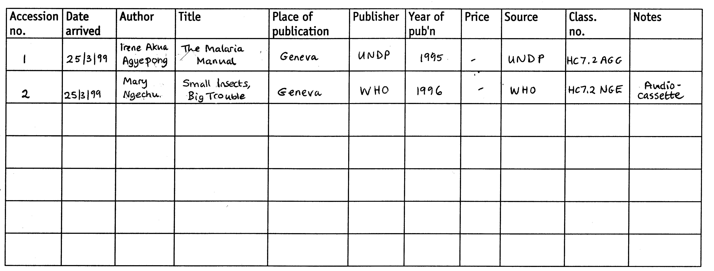

Example of an accessions register

4.6.3 How to record periodicals
Periodicals (journals and newsletters) are not normally recorded in the accessions register. They can be recorded in two ways. You can either use cards, using a separate card for each periodical, or you can use a ‘logging sheet’ produced on a typewriter or computer. The cards or logging sheets are filed alphabetically by periodical title in a card file or ring-binder file labelled ‘Periodicals’.

To complete a logging card or logging sheet, write the title of the periodical at the top. Enter the following details:

- how long the periodical will be kept (for example, indefinitely, one year, five years, current issue only)
- whether the volume will be bound when complete (tick if yes/cross if no)
- whether the periodical will be displayed on shelves (tick if yes/cross if no)
- circulation list: who should receive the periodical (names or initials).

TIP: Circulating periodicals
Some resource centres circulate periodicals to staff of the organisation that the resource centre is part of. A word of warning: some staff may keep the periodicals for a long time, meaning that resource centre users cannot see them. You could give staff a ‘return by’ date (allow a maximum of a week) and explain that you will collect the periodicals if they are not returned by this date. However, this is difficult to do for periodicals that are circulated to several staff. If you have a photocopier, you could circulate a photocopy of the contents page, so that staff can come to the resource centre to read articles of interest to them. You could also put a copy of the contents pages on a noticeboard.

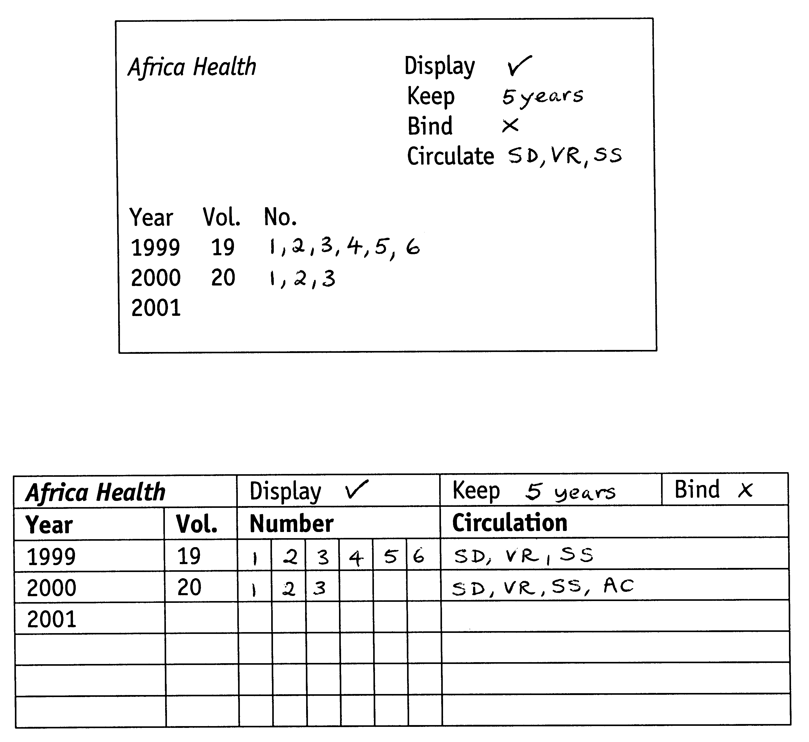Example of a logging card or logging sheet

4.7 Updating the collection

From time to time the collection needs to reviewed. This may include weeding out (removing) some materials, and deciding what new subject areas or types of material to include.

It is best to review the collection once a year, setting aside a few days, depending on the size of the collection. The review should be carried out by the resource centre officer in consultation with his or her supervisor, members of the resource centre advisory committee and/or other users. The supervisor or advisory committee should take responsibility for deciding what to remove or add.

The task will be easier if a needs assessment has recently been carried out, and if older editions of materials are weeded out regularly when new editions arrive.

4.7.1 How to review the collection
Before you weed out or add any materials, make sure that you know what materials are available elsewhere, either locally, or via a document delivery service.

- Remove any materials that are no longer suitable, such as those that are out of date, or those on subjects that are no longer of interest to users. You may be tempted to keep everything – resist the temptation! Focus on quality, not quantity.

- Remove any dirty or damaged materials. They waste space and can hinder access to more useful materials. They can also create the impression that the resource centre is not cared for. If the material is important to the collection and a new copy cannot be obtained, the material can be kept in a strong (labelled) envelope to prevent further damage or loss of pages.
You may be able to sell discarded materials as waste paper, or you may be able to offer them to another organisation if they are in good condition and of interest to them.

- Remember to amend records of materials that you have removed. Cross out records of weeded materials in the accessions register and write down the date that they have been weeded. Keep a running total of weeded materials. You will also need to amend or remove the catalogue cards.

4.8 Sample letters

4.8.1 Letter requesting free materials
Attach this letter to the order form (see Section 4.8.4)

Health Information Project
PO Box 111
Capital City
Ghana

Date __________________

Dear Sir/Madam

The Health Information Project is a registered non-governmental organisation that provides practical information to primary health care workers throughout Ghana. We have a resource centre containing 5,000 books, journals, training manuals, reports and audiovisual materials. We receive about 40 visitors and respond to about 15 written or telephone enquiries each week. We publish a newsletter, Practical Health, and we have produced a series of information packs and factsheets to meet requests for information on particular topics.

The Health Information Project receives most of its funding from the national government and overseas funding agencies. Some funds are also generated through membership fees and charges for services such as photocopying and hiring out the resource centre for meetings.

We regularly review the information needs of users through structured needs assessments and informal conversations. We continually need to add new materials to the collection to keep up-to-date with changing needs. However, our budget for new materials is very limited.

I am writing to ask if we could receive a free copy of the material described on the attached order form. We saw it advertised in_______________________________

The material will make a very useful addition to the collection. In particular, we will use it to________________________________________________________________

Thank you for considering this request. I look forward to hearing from you.

Yours faithfully

I C Books
Resource Centre Officer

4.8.2 Letter requesting exchange copy of periodical

Health Information Project
PO Box 111
Capital City
Ghana

Dear Editor

We have received a copy of your newsletter ______________________________________.
We would very much like to continue receiving it on a regular basis.

The Health Information Project is a registered non-governmental organisation that provides practical information to primary health care workers throughout Ghana. We have a resource centre containing 5,000 books, journals, training manuals, reports and audiovisual materials. We receive about 40 visitors and respond to about 15 written or telephone enquiries each week. We publish a newsletter, Practical Health, and we have produced a series of information packs and factsheets to meet requests for information on particular topics.

We would like to suggest that we exchange your newsletter with our newsletter, Practical Health. A copy of this is enclosed.

I look forward to hearing from you.

Yours faithfully

I C Books
Resource Centre Officer

Enc: Practical Health

4.8.3 Letter requesting sample copy of periodical

Health Information Project
PO Box 111
Capital City
Ghana

Date _________________

Dear Sir/Madam

The Health Information Project is a registered non-governmental organisation that provides practical information to primary health care workers throughout Ghana. We have a resource centre containing 5,000 books, journals, training manuals, reports and audiovisual materials. We receive about 40 visitors and respond to about 15 written or telephone enquiries each week. We publish a newsletter, Practical Health, and we have produced a series of information packs and factsheets to meet requests for information on particular topics.

The Health Information Project receives most of its funding from the national government and overseas funding agencies. Some funds are also generated through membership fees and charges for services such as photocopying and hiring out the resource centre for meetings.

We are interested in your publication ________________________________________
Please could you send a sample copy, and provide details of frequency, subscription rates and postage charges. Please could you let us know whether you offer any reduced rates, or whether you could offer your publication in exchange for our newsletter.

We look forward to receiving a copy of your publication.

Yours faithfully

I C Books
Resource Centre Officer

Enc: Practical Health

4.8.4 Order form for materials

Health Information Project
PO Box 111
Capital City
Ghana

Date: ____________________________________

Contact name: ____________________________

Our reference number: ______________________

To: ____________________________________

____________________________________

____________________________________

ORDER FORM FOR BOOKS, PERIODICALS AND AUDIOVISUALS

Title:

Author

Publisher/producer:

Edition: _________________________________

Publisher/producer:

Place of publication:

Year published/frequency:

Format and system (audiovisuals):

ISBN/ISSN: ______________________________

Number of copies: ________________________

Price per copy/subscription rate:

Please send the following, quoting our reference no:

- Pro-forma invoice

- Review copy

Thank you in advance for your help.

4.9 List of distributors

Academic institutions

Institute of Development Studies (IDS)

Publications Office, University of Sussex
Brighton BN1 9RE, UK
Fax: +44 1273 621202 or 691647

E-mail: publications@ids.ac.uk

Website: http://www.ids.ac.uk/ids

Johns Hopkins University
Bloomberg School of Public Health
Center for Communication Programmes

111 Market Place, Suite 310
Baltimore MD 21202, USA
Fax: +1 410 659 6266

Website: http://www.jhuccp.org/pubs

KIT Publishers
PO Box 95001
1090 HA Amsterdam, The Netherlands
Fax: +31 20 5688 286

E-mail: publishers@kit.nl

Website: http://www.kit.nl/books

Commercial publishers

Butterworth-Heinemann

Customer Service
Linacre House
Jordan Hill
Oxford OX2 8DP, UK
E-mail: bhmarketing@repp.co.uk

Website: http://www.bh.com

John Wiley & Sons, Ltd.
Customer Services Department
1 Oldlands Way
Bognor Regis
West Sussex PO22 9SA, UK
Fax: +44 1243 843303
E-mail: cs-books@wiley.co.uk
(See website for list of regional distributors in Singapore, Australia, Canada and the USA)
Website: http://www.wiley.co.uk

Macmillan Education
Macmillan Oxford
Between Towns Road
Oxford OX4 3PP, UK
Fax: +44 1865 405701
E-mail: elt@mhelt.com
Website: http://www.macmillaneducation.com

(See website for list of regional distributors all over the world)

Oxford Medical Publications

OUP Customer Services
Saxon Way West
Corby
Northants NN18 9ES, UK
Fax: +44 1536 746337

E-mail: book.orders@oup.co.uk

Website: http://www.oup.co.uk/medicine

ZED Books

7 Cynthia Street
London N1 9JF, UK
Fax: +44 20 7833 3960

E-mail: sales@zedbooks.demon.co.uk

Website: http://www.zedbooks.demon.co.uk

(See website for list of distributors in Africa, Asia, Australasia and North America)

Government organisations

Department for International Development (DFID)
1 Palace Street
London SW1E 5HE, UK
Fax: +44 1355 84 3632
E-mail: enquiry@dfid.gov.uk
Website: http://www.dfid.gov.uk

USAID Development Experience Clearinghouse
1611 N. Kent Street, Suite 200
Arlington VA 22209-2111
USA
Fax: +1 703 351 4039
E-mail: docorder@dec.cdie.org
Website: http://www.dec.org

German Foundation for International Development (DSE)
InWEnt Capacity Building International, Germany
Development Information Centre (IZEP)
Tulpenfeld 5
D-53113 Bonn, Germany
Fax: +49 228 2434 766
E-mail: izep@inwent.org
Website: http://www.dse.de/dse-e.htm

NGOs

ActionAid

Hamlyn House
Macdonald Road
London N19 5PG, UK

Fax: +44 20 7272 0899
E-mail: mail@actionaid.org.uk
Website: http://www.actionaid.org
(See website for regional offices in Bangkok, Guatemala City and Harare)

African Medical and Research Foundation (AMREF)

AMREF Book Distribution Unit
PO Box 30125, Nairobi
Kenya
Fax: +254 2 506112

E-mail: jireri@amrefhq.org
Website: http://www.amref.org/publications.htm

International Institute for Environment and Development (IIED)

3 Endsleigh Street
London WC1H ODD, UK
Fax: +44 20 7388 2826

E-mail: bookshop@iied.org

Website: http://www.iied.org/bookshop/index.html

International NGO Training and Research Centre (INTRAC)

PO Box 563
Oxford OX2 6RZ, UK
Fax: +44 1865 201852

E-mail: publications@intrac.org

Website: http://www.intrac.org

International Planned Parenthood Federation (IPPF)

Distribution Unit, International Office
Regent's College
Inner Circle
London NW1 4NS, UK
Fax: +44 20 7487 7900

E-mail: distribution@ippf.org

Website: http://www.ippf.org/pubs/index.htm

International Water and Sanitation Centre (IRC)

PO Box 2869
2601 CW Delft, The Netherlands
Fax: +31 15 219 09 55

E-mail: general@irc.nl

Website: http://www.irc.nl/home/pb/pbhome.htm

Oxfam
c/o BEBC Distribution
PO Box 1496, Parkstone
Poole
Dorset BH12 3YD, UK
Fax: +44 1202 712930

E-mail: oxfam@bebc.co.uk

Website: http://62.173.95.217/oxfam/index.asp

Program for Appropriate Technology in Health (PATH)
1455 NW Leary Way
Seattle, WA 98107-5136
USA
Fax: +1 206 285 6619
E-mail: publications@path.org
Website: http://www.path.org/materials.php

Save the Children Publications
c/o Plymbridge Distributors Ltd
Estover Road
Plymouth PL6 7PY, UK
Fax: +44 1752 202333
E-mail: orders@plymbridge.com
Website: http://www.scfuk.org.uk/functions/indx_pubs.html

Society for Participatory Research in Asia (PRIA)
42 Tughlakabad Institutional Area
New Delhi 110 062
India
Fax: +91 11 608 0183
E-mail: info@pria.org
Website: http://www.pria.org
Voluntary Health Association of India (VHAI)
Tong Swasthya Bhawan
40 Institutional Area, South of IIT
New Delhi 110 016
India
Fax: +91 11 6853708
E-mail: vhai@sify.com
Website: http://www.vhai.org

Women Ink.
International Women's Tribune Centre
777 United Nations Plaza
New York NY 10017
USA
Fax: +1 212 661 2704
E-mail: wink@womenink.org
Website: http://www.womenink.org

Specialist suppliers

African Books Collective (ABC)
The Jam Factory
27 Park End Street
Oxford OX1 1HU, UK
Fax: +44 1865 793298
E-mail: abc@africanbookscollective.com
Website: http://www.africanbookscollective.com

Earthscan Publications Ltd
120 Pentonville Road
London N1 9JN, UK
Fax: +44 20 7278 1142
E-mail: earthinfo@earthscan.co.uk
Website: http://www.earthscan.co.uk

The Hesperian Foundation
1919 Addison Street, Suite 304
Berkeley CA 94704
USA
Fax: +1 510 845 9141
E-mail: hesperian@hesperian.org
Website: http://www.hesperian.org

ITDG Publishing
103-105 Southampton Row
London WC1B 4HH, UK
Fax: +44 20 7436 2013
E-mail: marketing@itpubs.org.uk
Website: http://www.itdgpublishing.org.uk

PACT Publications
1200 18th Street NW, Suite 350
Washington DC 20036
USA
Fax: +1 202 466 5669
E-mail: books@pacthq.org
Website: http://www.pactpub.com

Teaching-aids At Low Cost (TALC)
PO Box 49
St Albans
Herts AL1 5TX, UK
Fax: +44 1727 846852
E-mail: talc@talcuk.org
Website: http://www.talcuk.org

TRIOPS Tropical Scientific Books
S Toeche-Mittler Distribution (STMV), Orders Dept
Hindenburgstrasse 33
D-64295 Darmstadt, Germany
Fax: +49 6151 314048
E-mail: triops@net-library.de
Website: http://www.triops.de/index_triops.htm

Tropical Health Technology
14 Bevills Close
Doddington, March
Cambridgeshire PE15 OTT, UK
Fax: +44 1354 740013
E-mail: thtbooks@tht.ndirect.co.uk
Website: http://www.tht.ndirect.co.uk

Subscription agents

Swets Blackwell
Swan House, Wyndyke Furlong
Abingdon Business Park
Abingdon
Oxfordshire OX14 1UQ, UK
Fax: +44 1235 857 501
E-mail: info@uk.swetsblackwell.com
Website: http://www.swetsblackwell.com
(See website for list of regional offices)

International organisations

International Labour Organisation (ILO)
ILO Publications
4 route des Morillons
CH-1211 Geneva 22, Switzerland
Fax: +41 22 799 6938
E-mail: pubvente@ilo.org
Website: http://www.ilo.org

Food and Agriculture Organization of the United Nations (FAO) Publications Distribution and Sales Section, Publications Division
Via delle Terme di Caracalla
00100 Rome, Italy
Fax: +39 6 52253152
E-mail: publications-sales@fao.org
Website: http://www.fao.org/publishing

Pan American Health Organization (PAHO)
The World Health Organization Regional Office for the Americas
525 23rd Street NW
Washington DC 20037
USA
Fax: +1 202 974 3663
E-mail: postmaster@paho.org
Website: http://publications.paho.org

UNAIDS
20 avenue Appia
CH-1211 Geneva 27, Switzerland
Fax: +41 22 791 4165
E-mail: unaids@unaids.org
Website: http://www.unaids.org

UNESCO

7 place de Fontenoy
75352 Paris 07 SP
France
Fax: +33 1 45 68 57 37

E-mail: publishing.promotion@unesco.org

Website: http://upo.unesco.org

UNDP & UNICEF (orders from North America, Latin America, the Caribbean and Asia and the Pacific)
United Nations Publications
Room DC2-0853, Dept. I004
New York NY 10017
USA

Fax: +1 212 963 3489
E-mail: publications@un.org

Website: http://www.un.org/publications

UNDP & UNICEF (orders from Europe, Africa and the Middle East)
United Nations Publications
Publications des Nations Unies
Section des Ventes et Commercialisation, Bureau E-4
CH-1211 Geneva 10, Switzerland
Fax: +41 22 917 0027
E-mail: unpubli@unog.ch

http://www.un.org/publications

World Bank

PO Box 960
Herndon, VA 20172-0960
USA
Fax: +1 703 661 1501

E-mail: books@worldbank.org

Website: http://publications.worldbank.org/ecommerce

World Health Organization - Regional Office for Africa (WHO/AFRO)

Cite du Djoue
PO Box 06 Brazzaville
Congo
Fax: +47 241 39503 / + 242 8 39503

E-mail: regafro@afro.who.int

Website: http://www.whoafr.org/home/informationsources.html

World Health Organization - South-East Asia Regional Office (WHO/SEARO)
World Health House, Indraprastha Estate
Mahatma Gandhi Marg
New Delhi 110 002
India
Fax: +91 11 2337 9507 or +91 11 2337 0972
E-mail: PandeyH@whosea.org
Website: http://w3.whosea.org

World Health Organization - Western Pacific Regional Office (WHO/WPRO)
Publications Unit
PO Box 2932
1000 Manila
Philippines
Fax: +632 5211036 or 5360279
E-mail: pub@wpro.who.int
Website: http://www.wpro.who.int/public/publication/publist.asp

World Health Organization - Eastern Mediterranean Regional Office (WHO/EMRO)
Abdul Razzak Al Sanhouri Street
PO Box 7608
Nasr City, Cairo 11371
Egypt
E-mail: dsa@emro.who.int
Website: http://www.emro.who.int

World Health Organization (WHO)
CH-1211 Geneva 27
Switzerland
E-mail: bookorders@who.int
Website: http://www.who.int/pub/en

