Section 3: Space, furniture and equipment

This section includes:
3.1 Location, size and structure
3.2 Planning the layout
3.3 Choosing furniture and equipment

3.1 Location, size and structure

3.1.1 Choosing a location
A resource centre needs to be easily accessible to the people who will use it. Its location will depend on who the users will be and what space is available. It could be somewhere users already go to regularly. For example, if most users will be district health workers, the resource centre could be in the district hospital, or in the district health offices where health workers collect their salary cheques. If most users will be community groups, the resource centre could be near a market place, bus station or school.

It is worth thinking ahead. The resource centre will probably be more sustainable if it attracts a wide range of users, such as practising health workers, medical and nursing students, health educators, members of community health committees, members of district management teams and so on.

It is best to find a location where there are no distractions such as noise and smells. The resource centre needs to be attractive and inviting. It needs to be accessible to everyone who will use it (including people with disabilities). It needs to be easy to find. It is important that it is well signposted and that directions are included in any publicity material (perhaps as a map).

3.1.2 Working out the size
The size of the resource centre will depend on how many people are expected to use it, and what activities are planned to take place in it. It will also depend on how much space is available. It will be necessary to negotiate with administrators to find a suitable site, in view of competing demands for space.

Resource centres can range from a set of shelves in someone's room, to one or more rooms dedicated to the resource centre and related activities. The site needs to be large enough to include:
- space for materials to be shelved
- work spaces for staff and users: desks, tables and chairs
- display area
- space for photocopier, duplicating machine or printing machine, if required
- space for a computer desk, if required
- space for meetings and possibly training activities
- storage space for materials waiting to be processed
- a secure place for expensive equipment such as a video recorder.

Tip: Size of resource centres
In order to aid decisions concerning the appropriate size of resource centres and libraries, guidelines were developed for libraries and resource centres in higher education institutions, which are also adopted by hospital and health resource centres. The recommendation is a minimum of 0.42m² per full time student with a minimum total area of 500m². For non-academic or training institutions, the calculations are usually based on the number of full time staff.

The guidelines also recognise the need for study space. This was originally calculated at a minimum of 1 space per 16 full time students. However due to the current emphasis on self-learning (which requires a greater use of resources), plus the increased use of technology such as computers and videos, it is now considered important to provide more space for study.

3.1.3 Ensuring a secure structure
The building in which the resource centre is housed needs to be in good condition to avoid damage from rainwater. Window shutters and a roof overhang help to provide protection from the weather. Mosquito netting over windows helps to protect both people and materials from insects, especially after dark.

The resource centre should be well lit. Natural light is comfortable for people to work in. However, materials need to be protected from strong sunlight.

Materials and equipment in the resource centre need to be secure from possible theft. It is important that windows and doors can be shut properly and locked when the resource centre is not in use.

3.2 Planning the layout
Before starting to arrange any furniture or equipment, it is best to draw a plan of the space available. The plan can be used to work out the most effective layout.

It is important to notice where the electric sockets are, so that computers, photocopiers and other electrical equipment can be placed near them. It is also important to find out which walls or pillars are strong enough to hold shelves.

Plenty of space needs to be allowed for shelves. The layout should ensure that:
- maximum use is made of the space available for shelving
- shelves are easily accessible to users
- shelves are away from direct sunlight as much as possible.

Activities that will take place in the resource centre need to be considered. For example, if the space will be used for meetings and training, the shelving will need to be arranged in a way that allows enough space for these activities. Space also needs to be allowed for wheelchairs to move about easily.

It is worth thinking about how to make the resource centre look attractive. Plans should include some colourful floor rugs, pot plants, and posters.

3.2.1 How to measure space for shelves
To work out how much shelf space you need, first find out how many books will go on a shelf. To do this, measure the width of a shelf. Then use some books to see how many will fit (not too tightly) on one shelf. Do this four times, using different books each time. Take the average of all four totals. For example, 45 + 57 + 49 +54 = 205 ÷ 4 = about 51.

Estimate the likely size of the collection over a particular period (such as five or ten years). To do this, take the present size of the collection, estimate the number of materials to be added each year (see Section 4.1.1: Developing a collection policy) and add the figures together. Remember to subtract the number of books that might be discarded. Divide the estimated size of the collection by the number of books per shelf to find out how many shelves you will require.

If shelf space is limited, remember this when you develop and review the collection policy. You will need to specify carefully what subjects and materials are to be added to the collection, and ensure that older or superseded materials (materials that are out of date) are weeded out regularly. You may have to limit the length of time that a particular type of material, such as periodicals, can be kept.

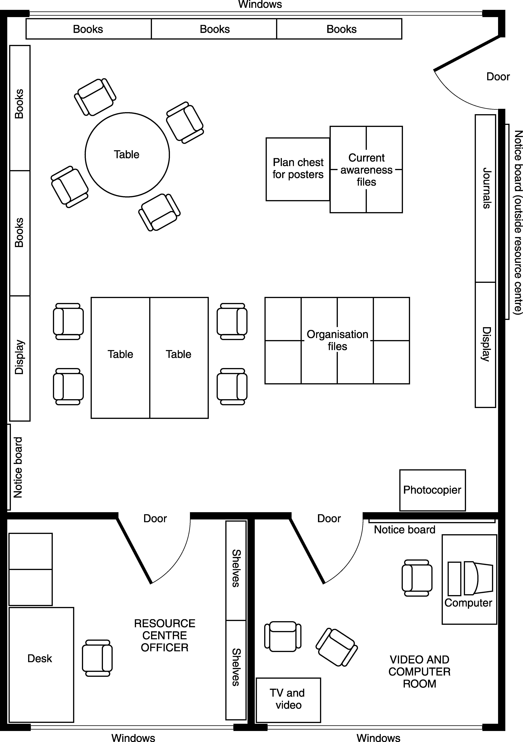

A possible layout for a medium size resource centre

3.2.2 Space for different uses
As well as space for shelves, the resource centre will need space for users, staff, training and meetings, storage, and displays.

People who use the resource centre need space to sit and read the materials. Space needs to be allowed for tables and chairs. Small tables allow more flexibility than large tables. They can be arranged separately or put together to make a larger table when required. Folding tables and chairs are convenient.

Access to a photocopier is useful. If the resource centre is very small, the photocopier could be put outside the resource centre itself, to keep the noise down. The photocopier may also need to be outside the resource centre if it is shared with other departments. However, the photocopier needs to be very close to the resource centre, so that users do not have to go far with materials that they wish to photocopy.

Resource centre staff need their own working space, either in the resource centre or in an adjoining room. Staff need desks, chairs, filing cabinets and shelves.

If the resource centre is in a room that is also used for training, staff need space in an adjoining room, so that they can continue to work when the resource centre is being used for training. If staff have a separate room, it is a good idea to situate the workspace for one or more staff near the main door of the resource centre, so that staff can see resource centre users and assist them if necessary.

Training and meetings are activities that can benefit from taking place in a resource centre, as materials that may be needed are already there. However, if the resource centre is a very busy place - for example, if it is in a training institution - meetings will distract people who are using the resource centre to study. In such cases, it is better to have a separate adjoining room for activities such as meetings, training sessions and showing videos. It is useful to include a noticeboard and table or display rack in this room, for displaying information from the resource centre that relates to the meeting or training session.

Storage space is needed for:
- newly received materials that are waiting to be processed
- older materials that are being repaired or withdrawn
- back issues of periodicals, if there is no space in the main room
- stationery and small equipment
- expensive equipment (which needs a locked cupboard).

Display space is needed for new materials, notices and so on. A table could be used to put new materials on, slanting display shelves could be used for periodicals, and a noticeboard could be used for announcements (see Section 3.3.2: Display equipment).
3.3 Choosing furniture and equipment

3.3.1 Shelving
The resource centre will need shelves for books, reports and pamphlet boxes. Adjustable shelves may be useful to accommodate materials of different heights.

Shelves need to be:
- made from good materials
- strongly made
- supported approximately every metre to prevent sagging
- at least 20cm (8 inches) deep, 30–35cm (12–14 inches) apart in height, with 10–20cm (4–8 inches) between the bottom shelf and the floor to enable them to be cleaned, and to prevent damage from flooding
- preferably without solid backs to allow maximum airflow
- preferably with a top shelf or cover to protect materials if the roof leaks
- braced (strengthened) at the back
- not too high to allow people to reach the top shelf.

Different sizes of shelving units should be selected to suit different spaces (such as low shelving units under windows and higher units along walls, or free-standing units in aisles).

Shelving units can often be purchased ready-made. They come in various sizes, with a varying number of shelves per unit, in different colours and materials (wood or metal). Alternatively, it might be possible to order shelves from a carpenter, which would probably be less expensive and would provide local employment.

Book supports are useful to keep books upright when the shelf is not full (see Section 5.5.1: Shelving materials). It is possible to buy supports or make them from wood, or to use a bean bag (cloth bag with beans or pebbles inside).

3.3.2 Display equipment
Different types of display equipment are useful for displaying different materials.

Noticeboards, bulletin boards or pin boards are useful for displaying information about forthcoming meetings, new materials and so on, and for users to exchange information about topics that they are interested in. At least one noticeboard should be placed in the resource centre. Another noticeboard should be placed outside the resource centre to catch the interest of people passing by, and to show resource centre opening times. Other noticeboards could be placed in other parts of the organisation, such as the reception area, and outside meeting rooms or training areas.

Slanting display shelves can be used to display the latest periodicals received. Back issues of periodicals can be stored underneath.

Wire racks, leaflet dispensers and hanging cloths can be used to display leaflets, pamphlets, periodicals and newsletters. They should only be used to display the most recently received issues of periodicals or newsletters. Older issues can be put in pamphlet boxes on the shelves.

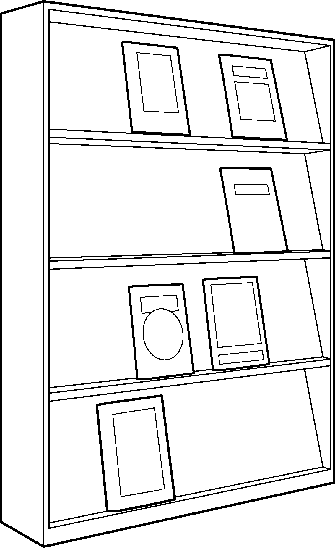

Slanting shelves are useful for displaying periodicals

TIP: How to make a hanging display
You can make a hanging display from cloth, for lightweight resource materials such as leaflets or newsletters.

Take a piece of cloth about 240cm (8 feet) by 100cm (3 feet). Turn under all the edges by about 2.5cm (1 inch). Fold the cloth in two, bringing the shorter edges together. Sew across the cloth about 5cm (2 inches) down from the fold, to make a space to insert a pole. Sew along the other edges, to sew the two folds of cloth together.

Mark places on the cloth to make pockets for leaflets or newsletters, by laying leaflets or newsletters on the cloth and drawing round them in chalk. Sew round the shapes, along the chalk lines.

Cut an opening across each shape about 8cm (3 inches) below the top of the shape. Turn under and sew the edges to prevent them from fraying.

Insert a wooden or metal pole in the space where the cloth is folded. Attach some string to each end and hang up the cloth on a hook.

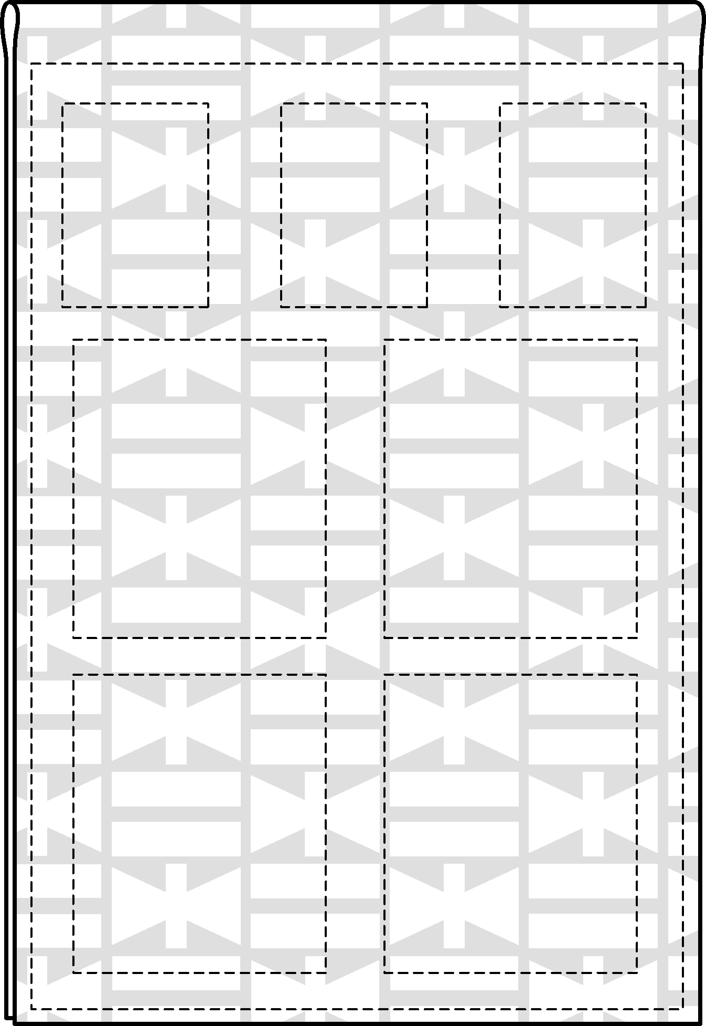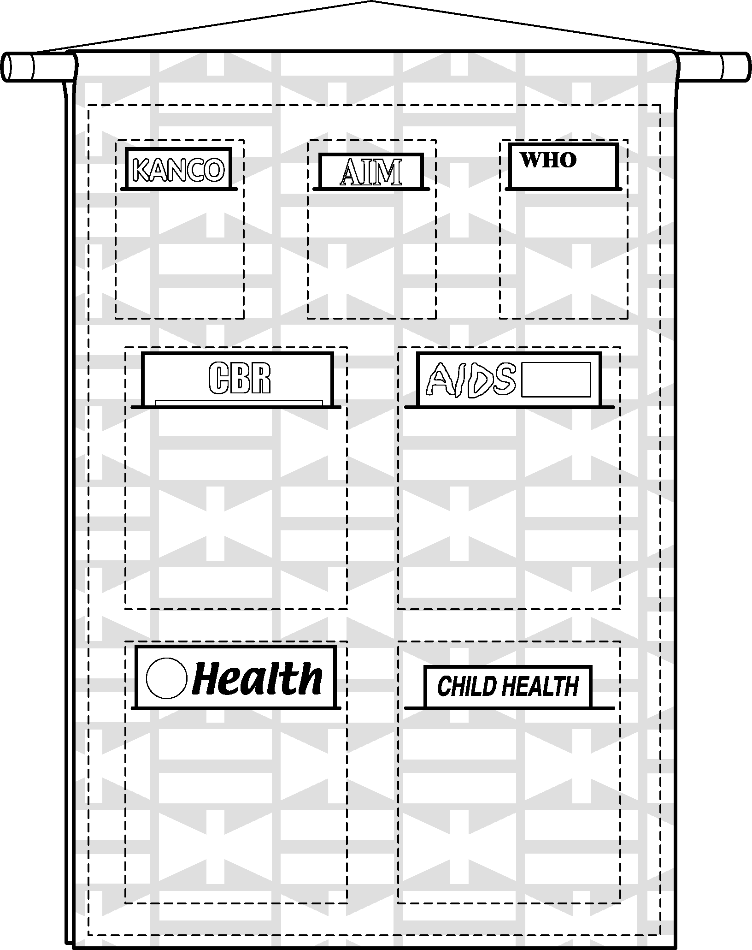

3.3.3 Other furniture and equipment
The resource centre will also need:
- tables, chairs and desks for staff and users
- locked cupboards for video cassettes and other audiovisual materials
- filing cabinets with suspended files for materials such as small reports and papers, leaflets, pamphlets, press cuttings and photographs
- pamphlet boxes for soft-cover materials, such as pamphlets, leaflets, periodicals and newsletters
- plan chest, cardboard box or portfolio for large materials such as drawings or posters
- communications equipment
- small items such as stationery.

Filing cabinets and pamphlet boxes can be used to store many of the same types of materials. Filing cabinets are more useful as it is easier to divide materials into clearly labelled groups, whereas pamphlet boxes usually have to contain materials on several topics to save space on the shelves. Filing cabinets also help to keep materials free of dust.

A list of furniture and equipment is given in Section 3.4.2.

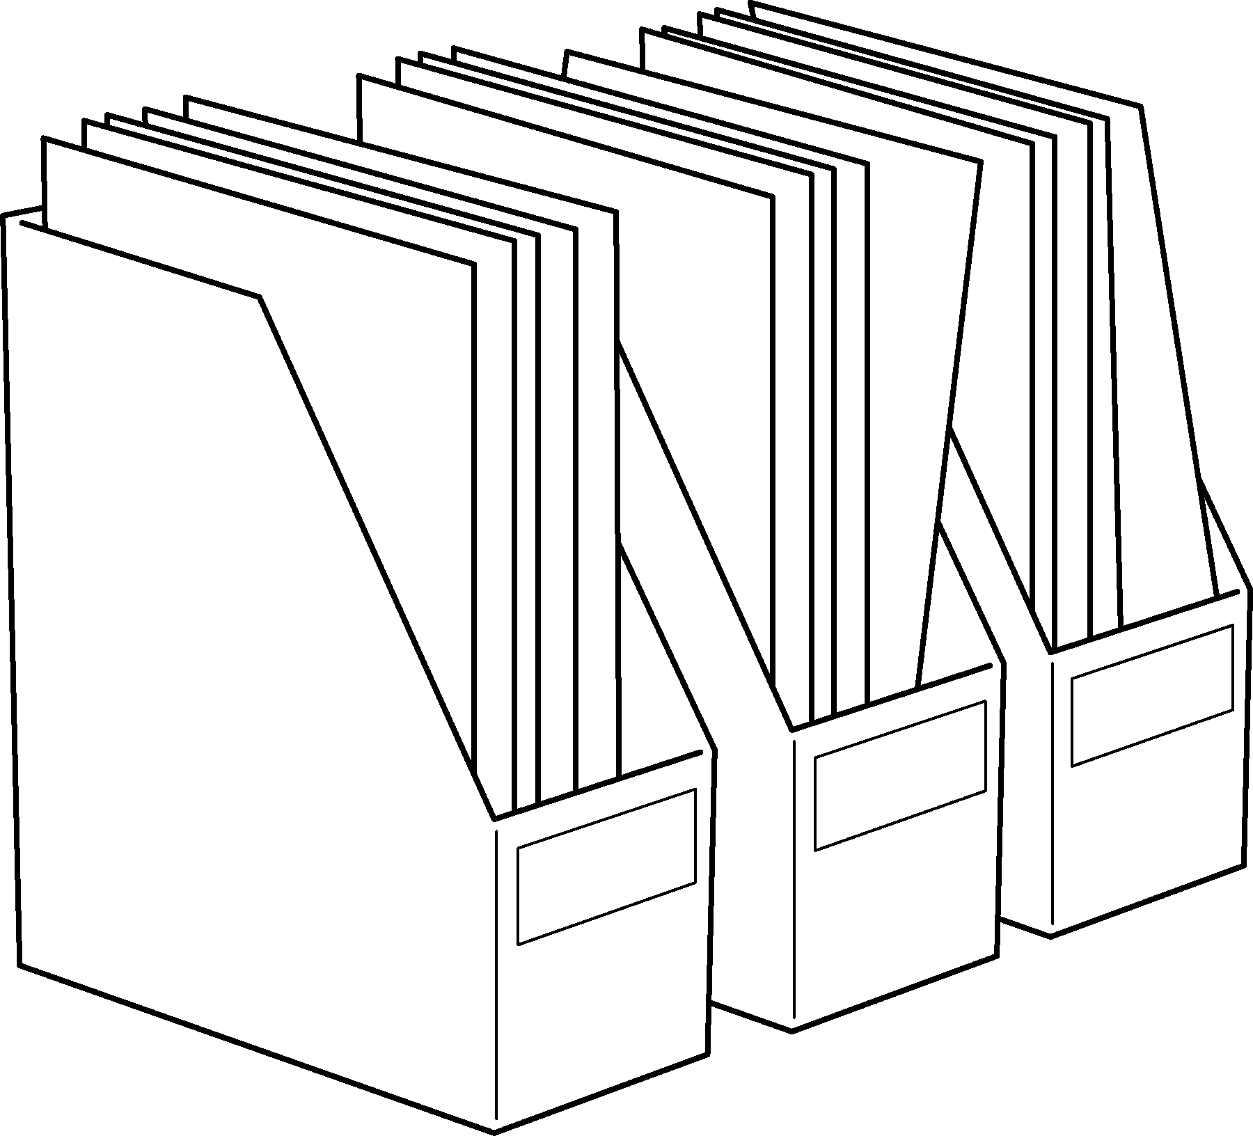

Pamphlet boxes are used for storing materials with soft covers

TIP: How to make a portfolio
Posters need to be stored flat. If you do not have enough room or funds for a plan chest, you could make a designer’s portfolio instead. You can stand the portfolio upright behind a set of shelves or beside a filing cabinet.

To make a portfolio, take two pieces of hardboard or very strong cardboard, a little larger than the largest poster to be stored. Make a flexible hinge by sticking strong sticky tape, such as gaffer tape, along one edge of each board, both sides.

Make flaps by attaching a narrow piece of card to each of the other three sides of one of the boards. Attach some cord to the outside edge of each of the two opposite flaps, and to the outside edge of each of the boards.

Tie the cords on the flaps together to prevent the posters from slipping out. Tie the other cords together to close the portfolio.

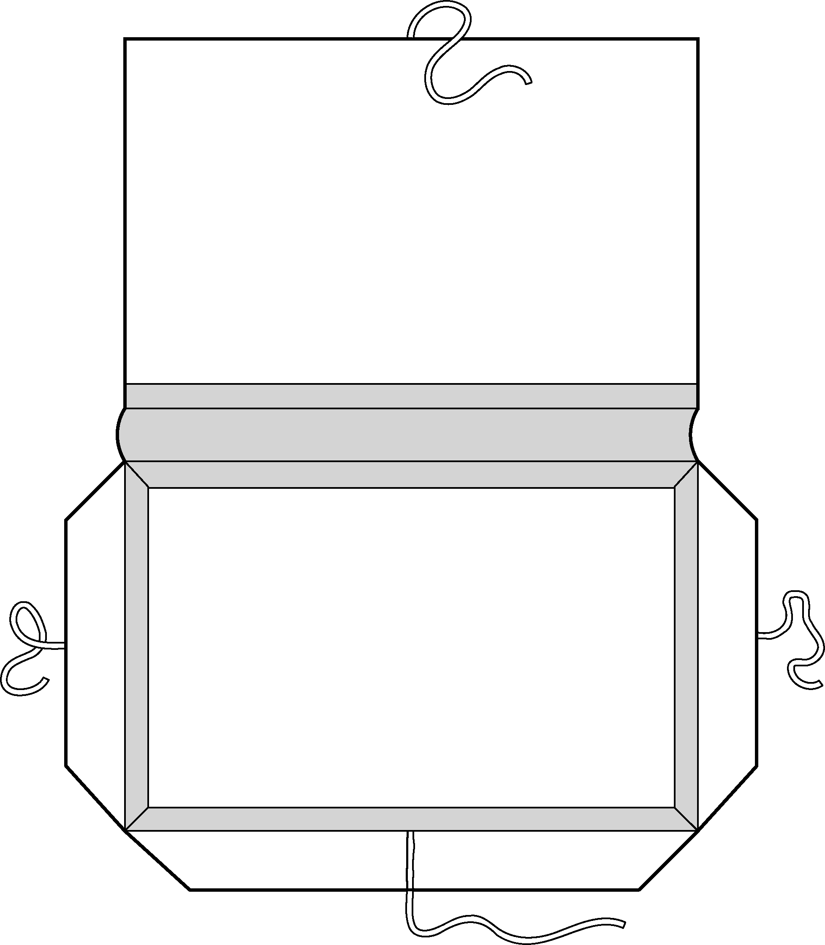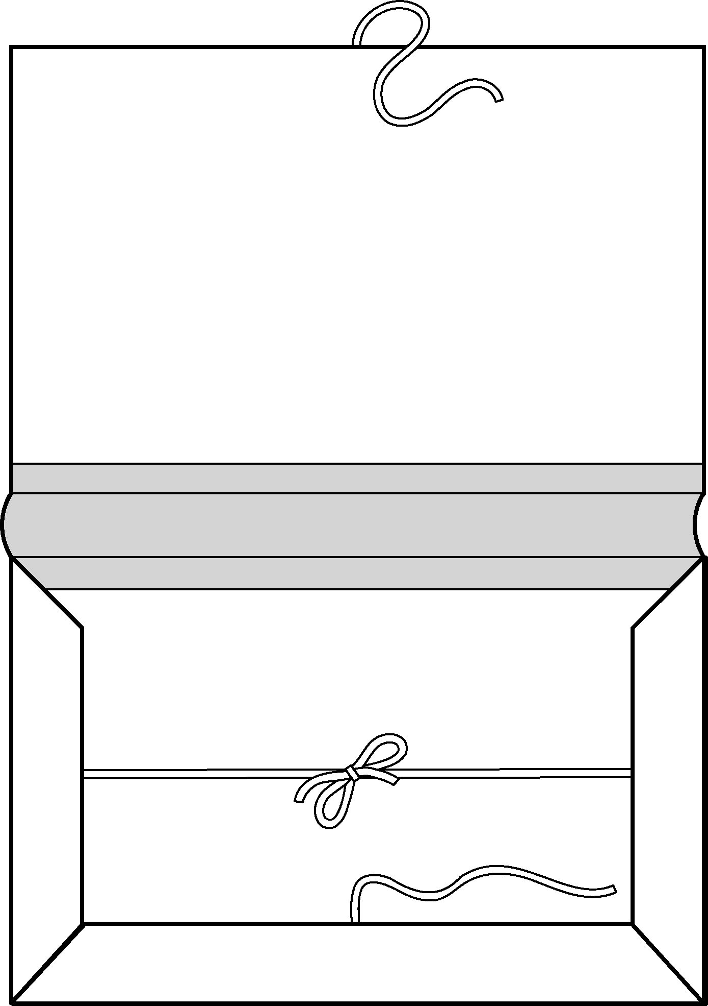

3.3.2 List of furniture and equipment
This is a list of furniture and equipment that the resource centre is likely to need, including consumables (items that will need to be replaced frequently). For more details of computer equipment, see Section 6.

Furniture | Consumables
Tables and chairs for users | Notebook for visitors
Desks (or tables) and chairs for staff | Notebook for record of borrowing
Desk for computer and printer | Notebook for statistics
Shelving | Notebook for accounts
Slanting shelves for displaying periodicals
Filing cabinet(s) | File folders
Wire racks for leaflets
Cupboard for TV and video
Card catalogue cabinet | Record cards
Stool
Floor rugs
Communications equipment | Consumables
Photocopier | Photocopier toner and paper
Overhead projector | Overhead transparencies
Slide projector | Spare bulbs for both projectors
Television
Video
Computer | Diskettes
Uninterruptable power supply (UPS) | Anti-virus updates (every 1–3 months)
Printer | Printer ribbons and paper
Telephone
Small equipment | Consumables
1 pair of sharp, medium-size scissors | Drawing pins | Plain white paper
1 pencil sharpener | Pencils | Coloured paper for displays
1 ruler | Erasers (rubbers) | Envelopes for mailing
1 stapler | Staples | Stamps
1 rubber stamp with name and address | Ballpoint pens | Glue or glue stick
of resource centre | Marker pens | Masking tape
1 date stamp | Carbon paper | Sticky labels (rectangular or
1 ink pad | Ink for ink pad | other shapes in several colours)
1 lockable petty cash box and keys | Paper clips | Sticky tape (plus special Scotch
1 or 2 waste bins | Rubber bands | 3M Magic Tape if possible)
At least 2 long, narrow boxes to hold | Black & white
record cards | permanent ink

3.4 Taking care of materials

Materials need to be protected from damage by sun, heat, damp, rainwater, fire, dust, animals and insects.

Humidity can cause materials to become mouldy. In dry climates, materials may be damaged by dust or termites. Air conditioning or good ventilation, and regular cleaning, will help to keep materials in good condition.

Fresh air and cleaning will help to control infestation by silverfish. Materials can be protected against ants by placing the legs of shelves in tins of water or a mixture of kerosene and water. If eating and drinking is allowed in the resource centre, the resource centre must be cleaned thoroughly, so that food crumbs do not attract insects or rodents. If necessary, the usual household insecticides should be used. However, they should be used (if at all) at the end of the day, so that they will not be breathed in by users, and the resource centre should continue to be cleaned regularly, so that residues do not build up.

Shelves should not be packed too tightly, as this prevents the flow of air, and can cause damage to materials when removing or re-shelving them.

Any materials that are damaged, but that are important to the collection and cannot be replaced, should be put in strong (labelled) envelopes to prevent further damage or loss of pages.
TIP: How to dust books
Dust books and other printed materials by holding them spine upwards and flicking through the pages to dislodge the dust away from the pages. If you try to dust them by wiping the edges of the pages with a cloth, this can push the dust further into the pages.

