CONTENTS

Foreword

Introduction

Section 1 Planning a resource centre
1.1 Assessing information needs
1.2 Strategic planning
1.3 Developing an action plan
1.4 Interviewing tips and sample questionnaires

Section 2 Management and finance
2.1 Staffing
2.2 Advisory committees
2.3 Financial planning
2.4 Fundraising and income generation

Section 3 Space, furniture and equipment
3.1 Location, size and structure
3.2 Planning the layout
3.3 Choosing furniture and equipment
3.4 Taking care of materials

Section 4 Developing the collection
4.1 Developing a collection policy
4.2 Format of materials
4.3 Sources of materials
4.4 Selecting materials
4.5 Obtaining materials
4.6 Receiving materials
4.7 Updating the collection
4.8 Sample letters
4.9 List of distributors

Section 5 Organising the information
5.1 Classifying materials
5.2 Developing a classification scheme
5.3 Assigning keywords
5.4 Cataloguing materials
5.5 Shelving, displaying and filing materials

Section 6 Computers, electronic communication and databases
6.1 Advantages of computers
6.2 Choosing a computer
6.3 Hardware and software
6.4 CD-ROMs
6.5 The Internet
6.6 E-mail services
6.7 The World Wide Web
6.8 Databases
6.9 Electronic resources
6.10 Review of database programs

Section 7 Information services
7.1 Developing a strategy
7.2 Staffing and opening hours
7.3 Introductory sessions and information skills
7.4 Advisory services
7.5 Lending
7.6 Photocopying
7.7 Document supply
7.8 Referral services
7.9 Current awareness services
7.10 Abstracts
7.11 Enquiries services
7.12 Information packs
7.13 Newsletters

Section 8 Making links and promoting the resource centre
8.1 Involving users
8.2 Promoting the resource centre
8.3 Networks and networking

Section 9 Monitoring and evaluation
9.1 Why monitor and evaluate?
9.2 Monitoring
9.3 Evaluation

Definitions

References

Further reading

acknowledgements

Many people have contributed to this manual. Thanks go particularly to Healthlink Worldwide’s project partners and others who have supported Healthlink Worldwide’s work in resource centre development, on which this manual is based. Thanks also go to Irene Bertrand, Andrew Buxton, Alfred Edwards, Jon Gamlon, Lucilda Hunter and special thanks to Wilson Lendita for reviewing the draft and suggesting improvements.

We are grateful to the Overseas Committee of the States of Jersey for funding the printing and distribution of the first edition of the manual, and to the Department for International Development, UK (DFID) for supporting various projects which enabled us to implement and test our ideas, notably those in the Middle East, Tanzania, Namibia, Kenya and Southern Africa.

This manual was compiled by Sheila O’Sullivan and Sarah Dutton, with contributions from Sue Mottram, Victoria Richardson, Margaret Elson, Suzanne Fustukian, Alison Condie and Andrew Chetley. It was edited by Celia Till, designed by Ingrid Emsden and laid out by Mary Helena.

The first edition was translated into Arabic by Malek Qutteini, Union of Palestinian Medical Relief Committees (UPMRC).

The illustrations are by David Woodroffe. Sources include Where there is no artist (Petra Röhr-Rouendaal), Let’s teach about AIDS and Health care together.

This revised edition of the Resource Centre Manual was updated by Victoria Richardson, Daphne Kouretas and Sarah Dutton

We are grateful to Misereor, Germany for funding the revision of this manual.

Resource Centre Manual: How to set up and manage a resource centre
Published by Healthlink Worldwide
Cityside, 40 Adler Street
London E1 1EE
UK

© Healthlink Worldwide 2003

First published 2000
Revised edition 2003
ISBN: 0 907320 57 0

Reproducing material and images
Healthlink Worldwide encourages the reproduction of material for non-profit uses. Please clearly credit Healthlink Worldwide as the source and send a copy of the publication to Healthlink Worldwide. Permission to reproduce images must be obtained from the photographer/artist or organisation as shown in the credit. Contact details are available from Healthlink Worldwide

Dedication

This manual is dedicated to the memory of two women who each in their different ways worked tirelessly to ensure better access to information: Dr Katherine Elliott, founder member of Healthlink Worldwide (formerly AHRTAG) and editor of Healthlink Worldwide’s first newsletter, Dialogue on Diarrhoea, and Dr Deborah Avriel, Chief of Health Literature Services, World Health Organization, who devoted much time and energy to lobbying for improved access to health information, especially for those in sub-Saharan Africa.

About Healthlink Worldwide

Healthlink Worldwide is a communication and information organisation that works in partnership with organisations in developing countries to strengthen: the local provision, use, and impact of health communication, and advocacy initiatives that increase participation and inclusion.

In order to do this effectively, we have developed an approach we call communicating through partnership, which emphasises:
- Strengthening the communications capacity of civil society organisations in the South
- Strengthening the voice of vulnerable and marginalised groups
- Linking information and communications activities with other work such as advocacy and lobbying.

Healthlink Worldwide works with over 20 partners in Africa, Asia, Latin America and the Middle East.

One of the principles behind Healthlink Worldwide’s work is a belief in information as a means of empowering people working in the front-line of health and development. We are a partner in the Source International Information Support Centre, which is designed to strengthen the management, use, and impact of information on health and disability (see over page for information about Source). We also publish resource lists, training materials, newsletters and booklets. You can find these in the Publications section of our website.

Healthlink Worldwide believes in working cooperatively with other agencies and provides consultancy and training in establishing resource centres, and information and knowledge management.

Until 1998, Healthlink Worldwide was known as AHRTAG (Appropriate Health Resources and Technologies Action Group).

For more information, please contact:

Healthlink Worldwide
Cityside
40 Adler Street
London E1 1EE
UK

E-mail info@healthlink.org.uk

or visit our website at http://www.healthlink.org.uk

About Source International Information Support Centre

Source is an international information support centre designed to strengthen the management, use and impact of information on health and disability. Source is a collaborative venture of four partners: Healthlink Worldwide; the Centre for International Child Health, which is a department of a university; Exchange, which is a health communication programme; and Handicap International, a disability and development NGO.

Source has a unique collection of over 20,000 health and disability information resources. These include published and unpublished materials, many of which are from developing countries and are not readily available elsewhere in one collection. Subject areas include adolescent and child health, disability, disease and disease control, evaluation, health communication, HIV/AIDS, information management, poverty and health, primary health care, and reproductive and sexual health.

Visit the Source website at www.asksource.info to access:
- Source bibliographic database which holds details of a unique collection of over 20,000 health and disability information resources, including books, manuals, reports, posters, videos and CD-ROMs. Many materials are from developing countries

- Source contacts database which allows you to search for organisations – including publishers, distributors, information providers and training organisations – working in health and disability worldwide

- Source newsletters and journals database which holds details of over 150 international newsletters, magazines and journals which are available free or at low cost to readers in developing countries, including links to the full text of the newsletter where possible.

The combined information support centre is designed to meet the information needs of individuals and organisations working in health, disability and development worldwide. These include health workers, researchers and students, non-governmental and government organisations and disabled people’s organisations.

Source is located in the library of the Institute of Child Health (ICH) and is open to visitors Monday to Friday from 9:00–17:00. For further information or to arrange a visit contact:
Assistant Librarian (Source Collection)
Source International Information Support Centre
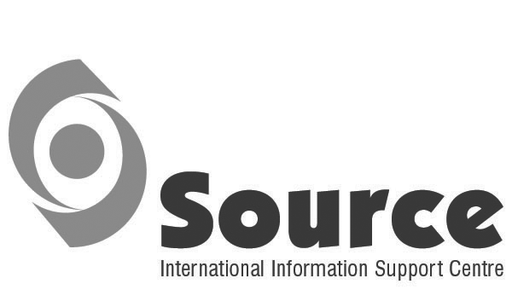
2nd Floor, Institute of Child Health
30 Guilford Street, London WC1N 1EH, UK
Tel +44 (0)20 7242 9789 x 8698
Fax: +44 (0)20 7404 2062
E-mail source@ich.ucl.ac.uk
Website www.asksource.info

Foreword

Since its foundation in 1977, Healthlink Worldwide (formerly AHRTAG) has supported primary health care as a means of achieving health for all, regardless of class, gender and race. Access to appropriate, relevant and up-to-date information about health and development issues plays a vital role in enabling health workers, managers and policy makers to make informed choices and improve their skills and knowledge.

One of Healthlink Worldwide’s key strategies has been to develop a resource centre and a range of information services focusing on the practical aspects of implementing primary health care programmes, and to provide technical support to resource centres. Healthlink Worldwide has supported the development of resource centres in a number of countries, primarily in Africa, Asia and the Middle East.

Over the years, Healthlink Worldwide has received many requests from organisations working in primary health care and related fields for support in setting up resource centres, such as: What issues should we consider when setting up a resource centre? What classification scheme should we use? Should we set up a resource centre, although we don’t have funds for a computer? What software would you advise us to use? How can we get people to use our resource centre? What ideas do you have to help us raise funds?

This manual provides the answers to these and many more questions. It contains practical information on all aspects of setting up and managing a resource centre, from planning, fundraising and finding a suitable location, to collecting and organising materials, developing information services, and monitoring and evaluating the work of the resource centre. It assumes that most readers will use manual systems for organising information, but also explains how computers can be used in resource centres, including e-mail, Internet and databases. It describes how to select database software, and contains a detailed review of three leading database programs. It includes a list of organisations and publications that can provide further information.

The content includes practical information, checklists, tips, examples and illustrations, which can be used for reference or training. Any pages may be photocopied to use as handouts or adapted for other materials, provided it is for educational purposes and the source is acknowledged.

This manual will be of use to people who are involved in setting up a resource centre, whatever its size. Some of the procedures described are more applicable to large resource centres containing several thousand materials – for example, a resource centre supporting a health service training institution – but much of the information also applies to smaller collections. The list of recommended reading in the Further Reading section includes publications that are relevant to different sizes of resource centre.

The information in this manual is drawn from the experience of Healthlink Worldwide and its partners in developing resource centres specialising in health and disability issues. Although it includes many references to the health sector, the same principles apply to resource centres specialising in other areas, such as education, environment or agriculture. It is hoped that this book will also be useful to those working in other sectors.

If you have any comments or suggestions for how to improve future editions, these would be very welcome.

Introduction

Who needs information?
Health, rehabilitation and community workers, educators, researchers, policy makers, managers, local communities and self-help groups all need information. Information is especially important for training health workers. There is plenty of evidence that access to the right information at the right time can mean the difference between life and death. Former executive director of UNICEF, James Grant, estimated that getting medical and health knowledge to those who needed it, and applying it, could have prevented 34 million deaths each year in the late 1980s.

Health sector reforms, changing disease patterns, and advances in technology make it vitally important that everyone involved in health care and promotion has access to relevant information – not only during their initial training, but throughout their working lives, to enable them to keep up-to-date and develop their skills.

Health workers and educators need basic data on the disease profiles of the local area, the latest techniques in diagnosis and treatment, how to communicate with patients, how to work with other sectors such as education or environment, ideas on how to undertake health promotion, and, increasingly, good information about how to run a health centre or a small health post.

Health, community and rehabilitation workers may need to gain a better understanding of the needs and rights of disabled people, and learn how to support disabled people to lead as full a life as possible.

Researchers need factual information on the area they are researching, and they need to know what research is being carried out, or has been completed and the results, to ensure that they are not duplicating any work.

Policy makers and managers need information on epidemiology, population size and characteristics, finances, staffing needs and facilities. They also need information on disadvantaged groups, the work of other sectors that contribute to health, and structures that promote community involvement.

Local communities and self-help groups need to learn how to participate in planning, implementing and evaluating programmes, promote healthy living and prevent disease, campaign for better services, promote their own services, and learn about their rights.

How can resource centres help?
Information plays an important part in the wider learning process – helping health workers to understand the context of their work, follow new approaches, undertake new responsibilities, improve their practice and remind them of basic concepts.
Learning takes place not only at workshops or on training courses, but also through discussions with colleagues, practical experience, and consulting newsletters, books and audiovisual materials. Resource centres can support a wide range of learning activities by making information available. By helping health workers learn, they can play a valuable part in improving the health of a nation.

A concern for equity – a key principle of primary health care – means that information, like health care, should be accessible to all. But in many developing countries, access to information is limited, especially information relevant to local conditions. Locally produced information is often unavailable, while information produced outside the local area may be inappropriate or too expensive.

Resource centres have an important part to play in improving access to information. A resource centre collects and organises materials that are useful to a particular group of people, such as health workers. Materials may be very varied, including training manuals, handbooks, reference books, directories, leaflets, posters, games, videos and samples of equipment.

However, a resource centre is much more than a collection of well organised materials. A resource centre actively seeks to share the information that it contains. Resource centre staff encourage people to use the materials. For example, they not only help people to find the materials they need, but they also disseminate information in the resource centre by producing and distributing locally adapted materials and information packs, holding training or discussion workshops, or arranging exhibitions.

A resource centre should aim to:
- create a pleasant environment for learning
- contain a relevant and accessible collection of resource materials (based on the actual needs of users)
- provide a range of information services
- encourage people to use the information in the resource centre
- help users gain access to information from other sources.

Development organisations usually prefer the term ‘resource centre’ to ‘library’ to emphasise that this is an active, attractive place where people can relax and enjoy themselves, talk to each other and take part in meetings and training activities.

A resource centre can be any size, from a trunk of books or a few shelves, to a whole room or several rooms. A resource centre may be part of an organisation or an organisation in its own right. It may serve staff within the same organisation, people from other organisations, members of the public, or a mixture. It may be staffed by a volunteer or someone for whom it is only part of their job, or by a team of professional librarians and information scientists who are responsible for different aspects of managing the collection and providing information services. A collection of materials in a hospital or health centre meeting room, a few shelves in a room at a training institution, or a room in a community centre – all these are resource centres.

The larger the resource centre, the more important it is to have systems for knowing what materials it contains and where to find them. With a small resource centre consisting of a couple of bookcases, it is easy for someone to look at all the materials and find what they need. Perhaps all that is needed is for the materials to be grouped together by subject, and the shelves to have labels showing which subjects are where. In a larger resource centre, however, it would take too long to look through all the shelves, so it becomes necessary to classify materials in more detail and list them in a catalogue (for a medium-sized resource centre) or on a computer database (for a large resource centre).

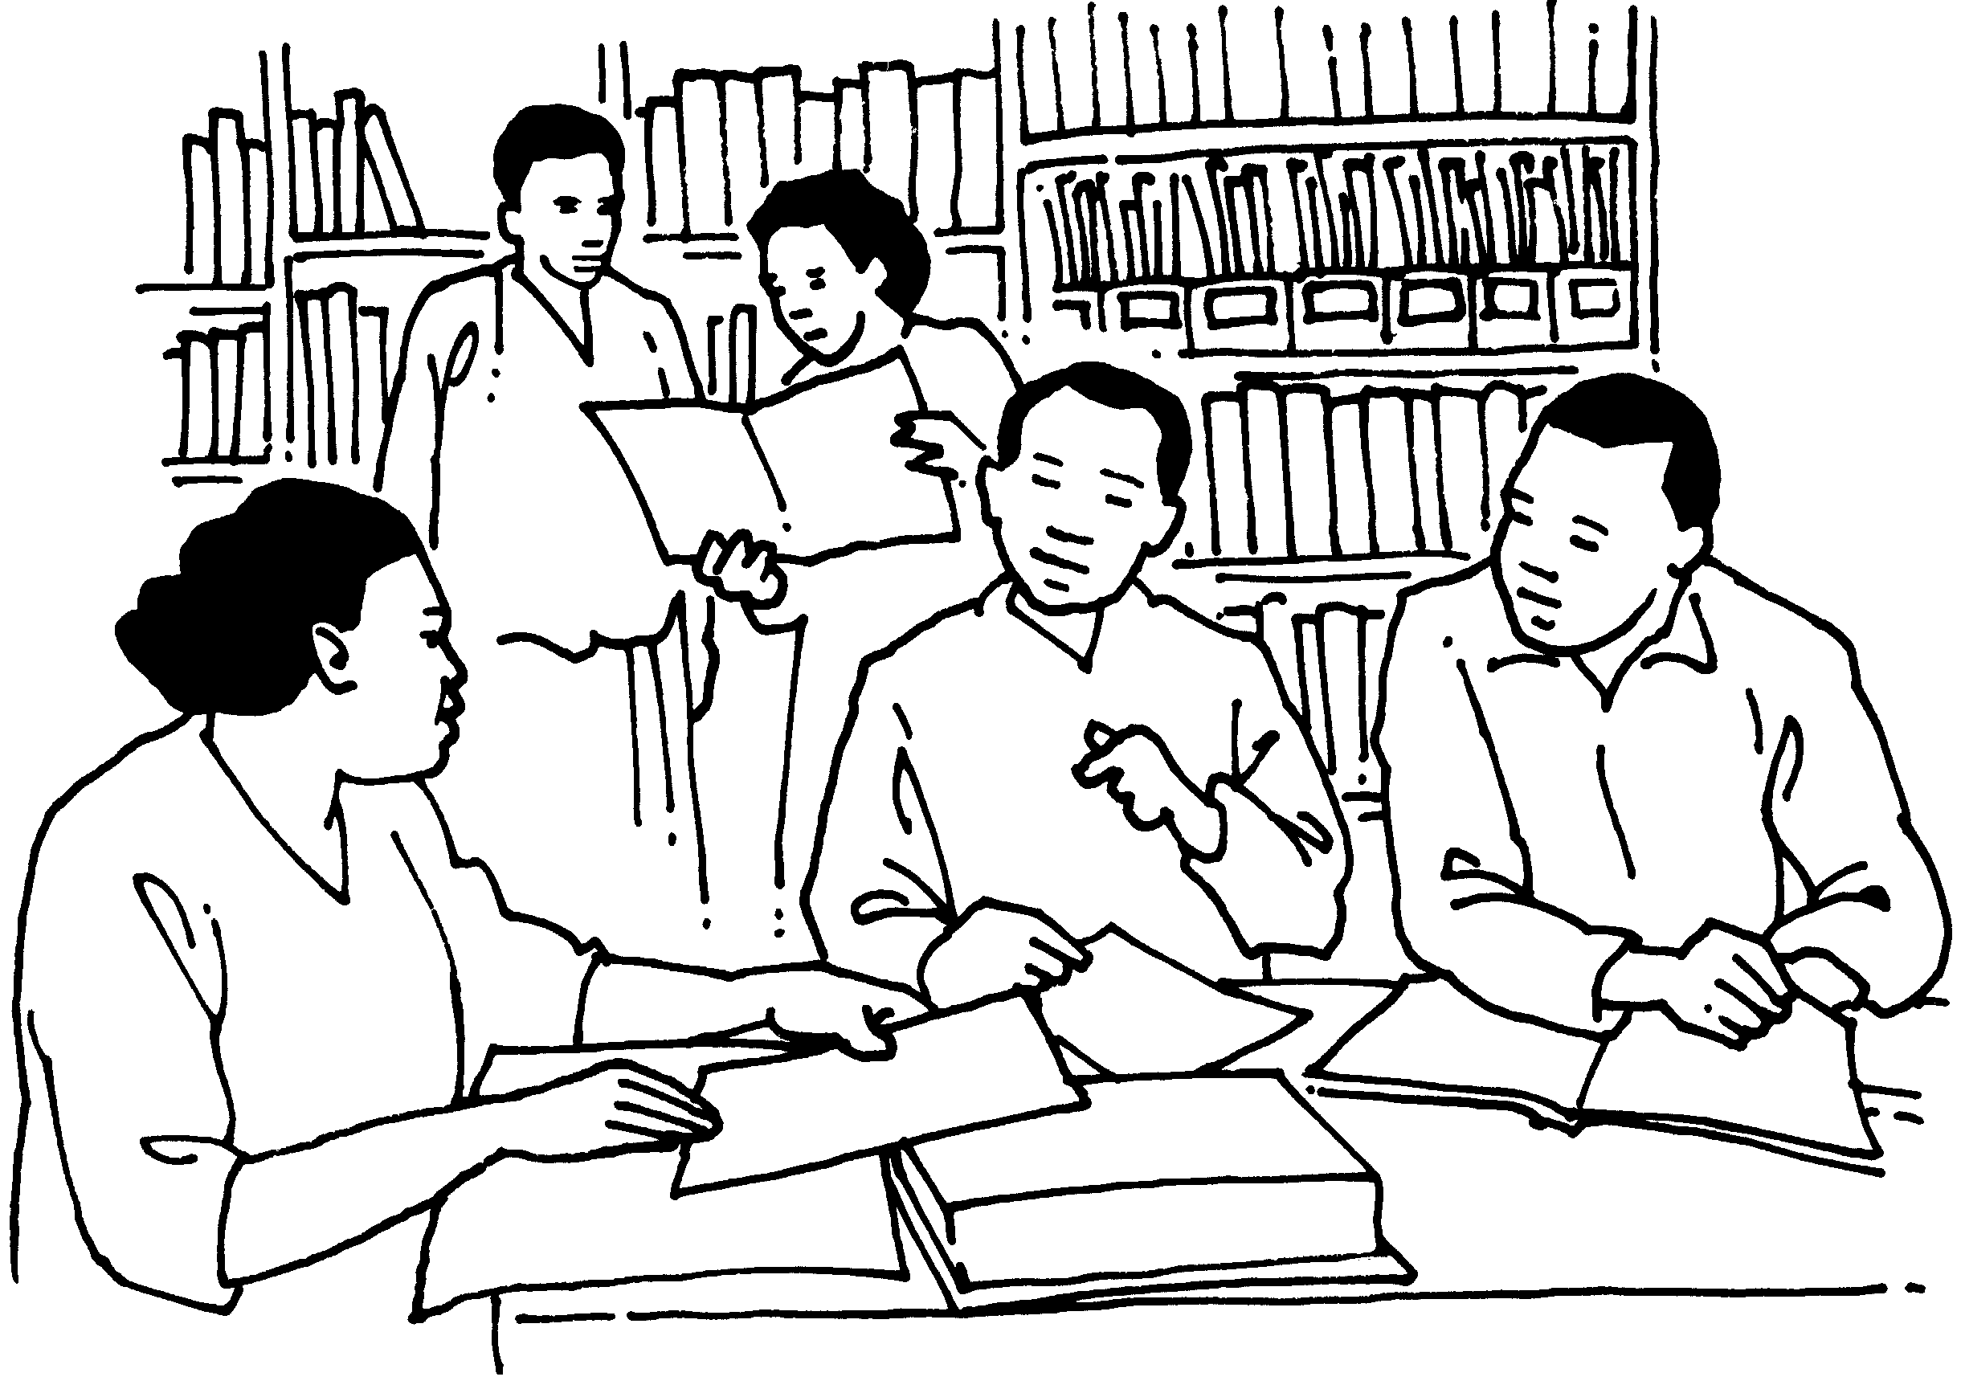
Whatever the size, all resource centres have the same aim – to meet the information needs of a particular group, or groups, of people.

A resource centre should be a pleasant environment for learning

CHECKLIST: What a resource centre can do

A resource centre can:

1. Make information accessible
- collect and organise materials
- provide access to materials that are up-to-date and relevant to users
- provide a pleasant environment for learning and training.

2. Encourage the use of information
- assist users to find relevant information and suggest how they can use it in their work
- provide materials to support training and health promotion
- provide information to those responsible for planning, managing and implementing health programmes, including district health management teams and community groups
- produce information packs and resource lists
- organise participatory workshops that use materials as tools for problem-solving
- work with teachers and trainers to identify resource materials for training activities
- offer an information and enquiry service
- develop ways to reach potential users.

3. Produce materials
- work with health teams and community groups to document their experience
- adapt, translate and produce health learning materials.

4. Strengthen links with other organisations
- list local, national, regional and international organisations working in health and related fields
- develop contacts between organisations working in similar fields, such as the Ministry of Education, Ministry of Water and Sanitation, non-governmental organisations (NGOs) and community organisations
- identify other sources of information.

